**Nominated garages for mechanical tests**

Bordon Tyre & Exhaust Centre: 01420 477655

Windmill Garage, Horndean: 02392 571003

Froxfield Service Station: 01420 587403

Station Garage, Liphook: 01428 722663

Phillips Garage Ltd, Alton: 01420 83273

Petersfield Exhaust and Tyre Services Ltd: 01730 233422

**Licensing**

Direct Dial: 01730 234379/89/99

Email: [licensing@easthants.gov.uk](mailto:licensing@easthants.gov.uk)

**Licensing**

Direct Dial: 01730 234379/89/99

Email: [licensing@easthants.gov.uk](mailto:licensing@easthants.gov.uk)

**Nominated garages for mechanical tests**

Bordon Tyre & Exhaust Centre: 01420 477655

Windmill Garage, Horndean: 02392 571003

Froxfield Service Station: 01420 587403

Station Garage, Liphook: 01428 722663

Phillips Garage Ltd, Alton: 01420 83273

Petersfield Exhaust and Tyre Services Ltd: 01730 233422

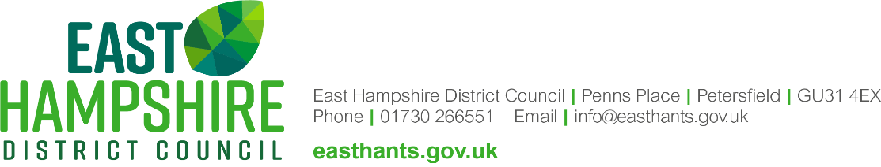



**License Fee 2023/2024**

**Drivers**

Combined Hackney Carriage/Private Hire Driver and Restricted Driver New 3 year £235.00

New 1 year £173.00

Renewal 3 year £204.00

Renewal 1 year £168.00

Replacement ID badge £ 19.00

Replacement driver licence £ 14.00

Change of address £ 21.00

Change of name &/or address £ 29.00

**Vehicles**

Hackney Carriage and Private Hire New £161.00

Renewal £161.00

Temporary £ 69.00

Transfer of Vehicle Proprietor £ 40.00

Change of vehicle registration £ 55.00

Replacement Vehicle Licence £ 14.00

Replacement Vehicle Plate £ 27.00

Private Hire Vehicle Plate Exemption £ 54.00

**Private Hire Operator**

Operator Licence - New/Renewal 5 year £355.00

New/Renewal 1 year £146.00

**Other**

Driver Knowledge Test: £ 41.00

Plate Fixings (inc VAT): Back Plate Platform: £ 12.00

Brackets (down): £ 21.60

Pair of Pouches £ 8.40

**For our nominated garages for mechanical test please turn over.**

**License Fee 2023/2024**

**Drivers**

Combined Hackney Carriage/Private Hire Driver and Restricted Driver New 3 year £235.00

New 1 year £173.00

Renewal 3 year £204.00

Renewal 1 year £168.00

Replacement ID badge £ 19.00

Replacement driver licence £ 14.00

Change of address £ 21.00

Change of name &/or address £ 29.00

**Vehicles**

Hackney Carriage and Private Hire New £161.00

Renewal £161.00

Temporary £ 69.00

Transfer of Vehicle Proprietor £ 40.00

Change of vehicle registration £ 55.00

Replacement Vehicle Licence £ 14.00

Replacement Vehicle Plate £ 27.00

Private Hire Vehicle Plate Exemption £ 54.00

**Private Hire Operator**

Operator Licence - New/Renewal 5 year £355.00

New/Renewal 1 year £146.00

**Other**

Driver Knowledge Test: £ 41.00

Plate Fixings (inc VAT): Back Plate Platform: £ 12.00

Brackets (down): £ 21.60

Pair of Pouches £ 8.40

**For our nominated garages for mechanical test please turn over.**

**Licence Fees – 2020/2021**

**Drivers**

Combined Hackney Carriage/Private Hire Driver and Restricted Driver New 3 year £235.00

New 1 year £173.00

Renewal 3 year £204.00

Renewal 1 year £168.00

Replacement ID badge £ 19.00

Replacement driver licence £ 14.00

Change of address £ 21.00

Change of name &/or address £ 29.00

**Vehicles**

Hackney Carriage and Private Hire New £161.00

Renewal £146.00

Temporary £ 69.00

Transfer to Replacement Vehicle £ 65.00

Transfer of Vehicle Licence Type £ 65.00

Transfer of Vehicle Proprietor £ 40.00

Change of vehicle registration £ 55.00

Replacement Vehicle Licence £ 14.00

Replacement Vehicle Plate £ 27.00

Private Hire Vehicle Plate Exemption £ 54.00

**Private Hire Operator**

Operator Licence - New/Renewal 5 year £355.00

New/Renewal 1 year £146.00

**Other**

Disclosureand Barring Service (Enhanced, £44), (Standard £26)

DVLA Licence Mandate: £ 5.75

Driver Knowledge Test: £ 41.00

Plate Fixings (inc VAT): Back Plate Platform: £ 12.00

Brackets (down): £ 21.60

Pair of Pouches £ 8.40

**For our nominated garages for mechanical test please turn over.**