How do you decide how much my household pays?

Almost every home must pay Council Tax, whether it is a house, bungalow, flat, maisonette or a mobile home and whether it is owned or rented. Each home is in one of eight valuation bands, according to how much it was worth on 1 April 1991. Your Council Tax bill shows the band your home is in.

You can also check this online at www.voa.gov.uk. Valuations bands are not decided by EHDC. If you think your home should be in a different band, please write to the Listing Officer at the Valuation Office Agency, Overline House, Central Station, Blechynden Terrace, Southampton, SO15 1GW. Telephone: 03000 501 501.

 | Value as at 1 April 1991
Band A | Up to £40,000
Band B | Over £40,000 up to £52,000
Band C | Over £52,000 up to £68,000
Band D | Over £68,000 up to £88,000
Band E | Over £88,000 up to £120,000
Band F | Over £120,000 up to £160,000
Band G | Over £160,000 up to £320,000
Band H | Over £320,000

Is my property exempt?

Some homes, known as exempt properties, do not have to pay Council Tax. These include properties lived in only by students or people with severe mental impairment and, in some cases, empty properties. If you think your property could be exempt, please contact us.

Does someone in your household have a disability?

We can reduce your Council Tax if anyone in your household (including children) has a disability and your property has an extra bathroom, kitchen or room to meet the needs of the disabled person.

The reduction is also available if they use a wheelchair indoors. There are discounts and exemptions available to people who are severely mentally impaired. Please contact us for further details.

Am I entitled to a discount or Council Tax Support?

Your Council Tax bill assumes that there are two adults in your home. If only one adult lives there (as their main home), we will reduce the bill by a quarter (25%). If we give you a discount, you must tell us about any change in your circumstance, which could affect your entitlement. If you don’t you may have to pay a fine.

If you have successfully applied for Council Tax Support (CTS), the amount of the reduction should be shown on your bill. If it is not shown and we have said you will qualify, we will send you an amended bill as soon as possible. Your CTS will show as a reduction on the bill.

If you are getting CTS, you must remember to tell the council straight away of any change to your income, savings, the number of people in your household or any other change that might affect your entitlement.

You must tell the council within 21 days of the change happening. If you do not tell us within 21 days, you could be prosecuted. If your circumstances change and you are paid too much CTS, you will be required to repay it.

If you have any questions about your CTS please email the Benefits Section at benefits@easthants.gov.uk or telephone our Customer Services Team on 01730 234175.

Data Sharing

This authority is under a duty to protect the public funds it administers, and to this end may use the information you have provided for the prevention and detection of fraud.

It may also share this information with other bodies responsible for auditing or administering public funds for these purposes.

For further information contact Cheryl Lincoln, Governance and Information Manager, on 02392 446568.

How your bill is calculated

We take great care in calculating your bill correctly with the information that you have given us. If you believe that the bill is incorrect, please write to us first. If you disagree with our decision and then wish to appeal, we will give you full details on how to make an appeal. Making an appeal does not allow you to withhold payment. If an appeal is successful, you will be entitled to a refund if you have paid too much.

How the money is spent

This table shows how much we plan to spend on each of the main services we provide. This spending will help meet the priorities in our strategic plan.

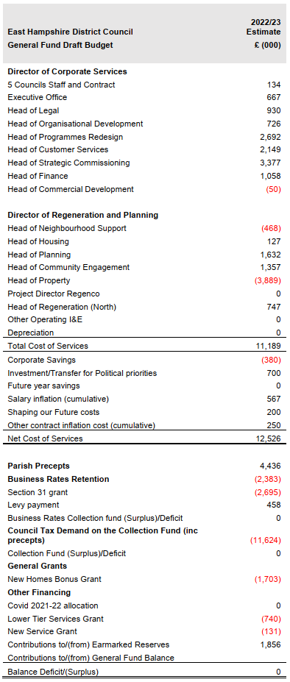

Council Tax charges

The table below sets out the 2022/23 Council Tax charges for each property band. The changes shown below assume at least two non-exempt adult residents, if only one resident, a 25% discount applies.
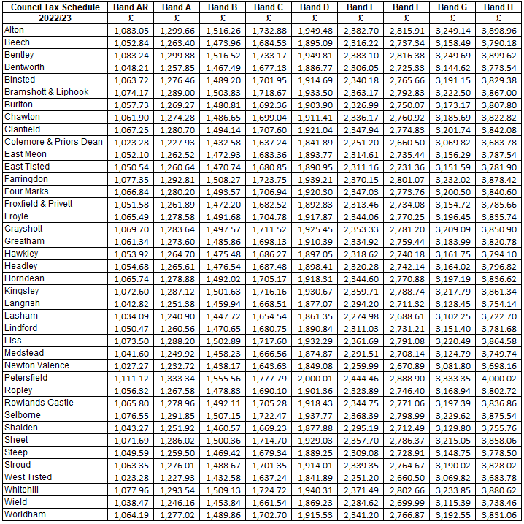

*AR - If you qualify for disabled person’s relief and live in an A Band property, your Council Tax will be charged at the AR level.

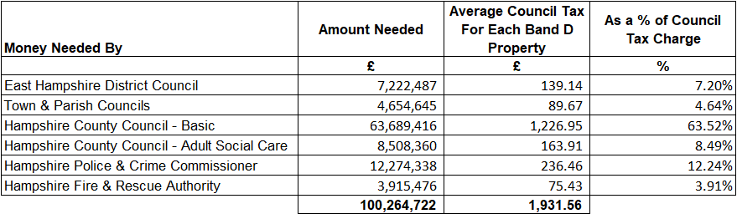

Parish and Town Council Budgets

The table below provides the budget requirements and Band D charges of the Parish and Town Councils in East Hampshire District Council's area.
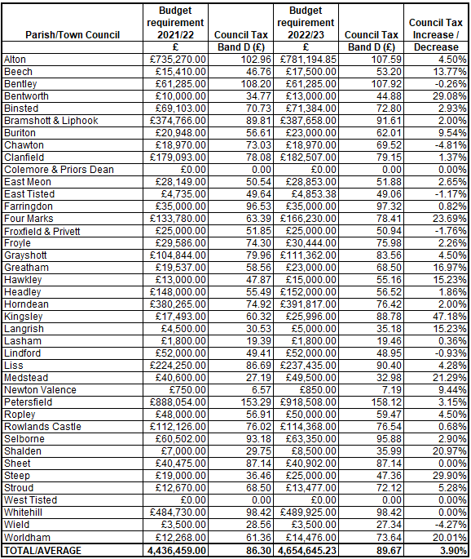

Parish Spend over £140,000

The table below details local councils with budget requirements of more than £140,000 in 2022/23.
Requests for further information should be made to the appropriate town or parish clerk whose telephone numbers are: Alton 01420 83986; Bramshott & Liphook 01428 722988; Clanfield 02392 596353; Four Marks 01420 768284; Headley 01428 713132; Horndean 02392 597766; Liss 01730 892823; Petersfield 01730 264182; Whitehill 01420 473123

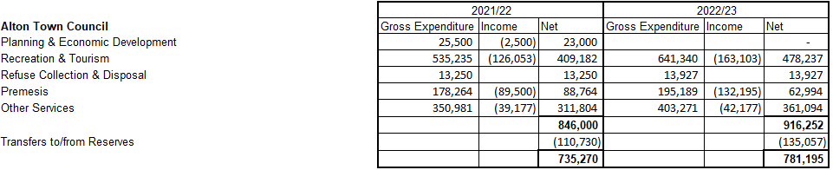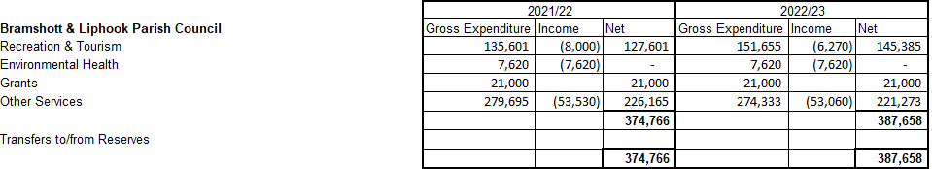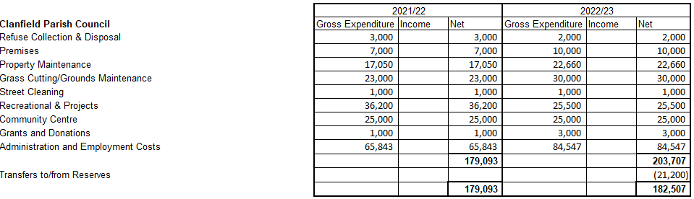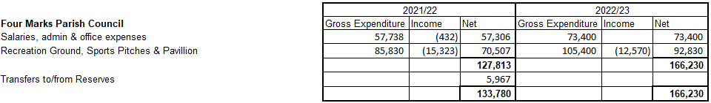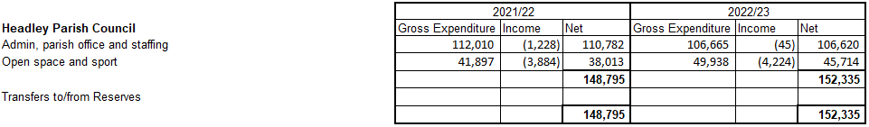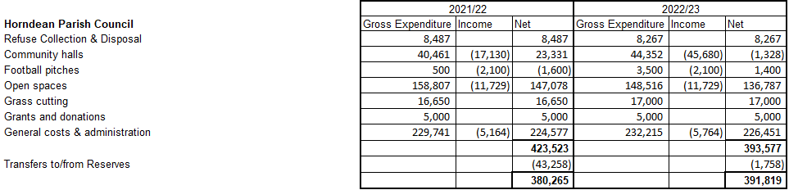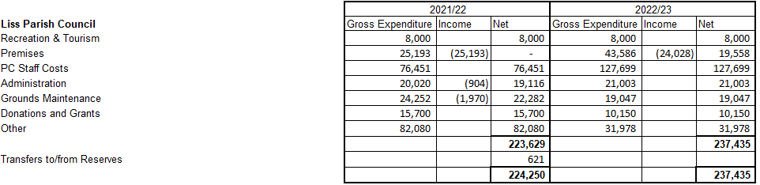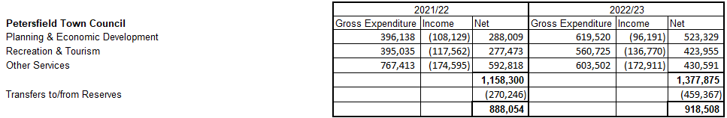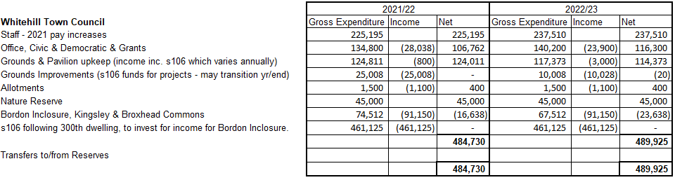

If you have any questions about the content of any of these pages please leave a comment on our website www.easthants.gov.uk.

