Bentley Parish
Modified Neighbourhood Plan 2021-2028

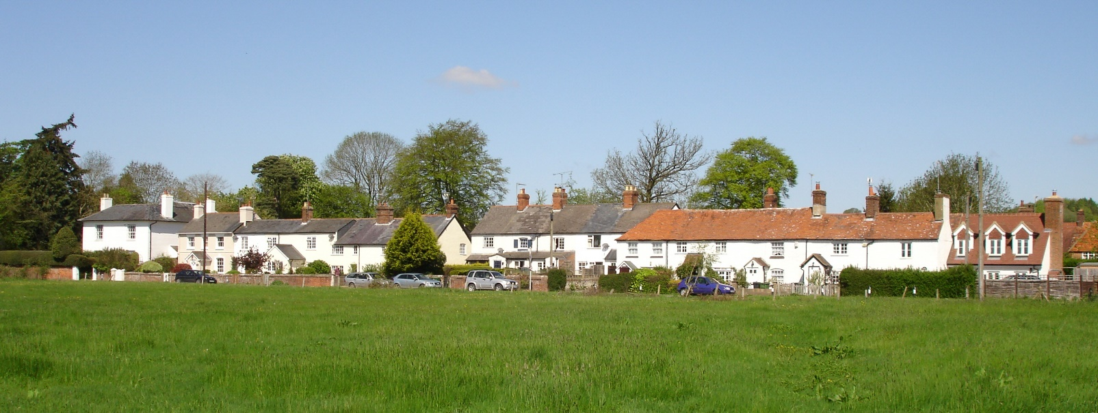

Published by
Bentley Parish Council for adoption by East Hampshire District Council.

July 2025

Contents
Foreword 4
List of Land Use Policies 5
1. Introduction 6
Purpose 6
Sustainability Appraisal (& Strategic Environmental Assessment) 7
Habitats Regulations 7
The Next Steps 7
2. Background Information and Evidence Base 8
Background 8
Location 8
Layout 9
Bentley History 9
The Human Character of Bentley 10
Bentley Conservation Area Character Appraisal 10
Community 12
Amenities 13
Population and Housing 14
Employment 15
Transport 15
Housing and Development 16
Adjacent Villages 18
Health 19
Community views 19
3. Planning Policy Context 22
The Local Plan Part 1 – Joint Core Strategy (2014) 22
The Local Plan Part 2 – Housing and Employment Allocations 24
The Bentley Plan (2014) 24
The Emerging East Hampshire Local Plan 26
4. Vision, Objectives and Land Use Planning Policies 27
The Vision 27
The Vision for Bentley Parish 27
Objectives & Measures 28
Monitoring & Review 28
Policy Issues 29
Land Use Policies 29
Policy BEN1: Spatial Plan 30
Policy BEN2: Development Principles 31
Policy BEN3: Design 32
Policy BEN4: Local Heritage Assets 35
Policy BEN5: Recreation Ground 37
Policy BEN6: Education 38
Policy BEN7: Community Facilities 39
Policy BEN8: Local Employment 40
Policy BEN9: Traffic Impacts 41
Policy BEN10: Green Infrastructure 42
Policy BEN11: Local Green Spaces 44
Policy BEN12: Sustainable Drainage and Wastewater 45
Policy BEN13: Dark Skies 47
5. Implementation 48
Development Management 48
Extension of the Conservation Area 48
Infrastructure Projects 48
Appendix A – Evidence Base 52
Appendix B – Bentley Settlement Boundary 54
Appendix C – Local Heritage Assets 55

Foreword

“Bentley’s Neighbourhood Plan allows us to have a say in any future local development by providing a set of land use policies which are specific to our parish. These policies together with East Hampshire District Council’s, more general, Local Plan policies form a Development Plan for Bentley such that we are better able to preserve the distinctive character and environment of our rural community.

Our original Neighbourhood Plan, made in 2016, was one of the first in East Hampshire and, indeed, one of the first in the UK. Plans need to evolve to meet new challenges and this revision has given us the opportunity to improve our plan, learning from our own experiences and from other communities that have made plans since.

It has been a fairly arduous task to complete this revision, given the circumstances of the past few years, and I would like to thank the Neighbourhood Planning Group and especially their Chairman, Chris Mace, for bringing the revision together; a sterling effort by all.”

John Fuller
Chairman for Bentley Parish Council

List of Land Use Policies

Set out in the table below is a summary of the proposed material modifications to the made Bentley Neighbourhood Plan.

Modified Plan Policy Numbers & Titles | Made Plan Numbers
Policy BEN1: Spatial Plan | 1(modified)
Policy BEN2: Development Principles | 2 (modified)
Policy BEN3: Design | 2(modified)
Policy BEN4: Local Heritage Assets | 2 (modified)
Policy BEN5: Recreation Ground | 3
Policy BEN6: Education | 4(modified)
Policy BEN7: Community Facilities | New
Policy BEN8: Local Employment | New
Policy BEN9: Traffic Impact | New
Policy BEN10: Green Infrastructure | New
Policy BEN11: Local Green Spaces | 5(modified)
Policy BEN12: Sustainable Drainage and Wastewater | 6(modified)
Policy BEN13: Dark Skies | New

1. Introduction

Purpose

1.1 Bentley Parish Council (‘the Parish Council’) is proposing to modify the made Bentley Neighbourhood Plan 2016 – 2028 (‘the Original Plan’) for the area designated by East Hampshire District Council (EHDC) on the 23rd of October 2014. The area coincides with the parish boundary as shown on Plan A.

1.2 The purpose of this modified Bentley Parish Neighbourhood Plan (BPNP) is to update, replace and/or delete policies of the Original Plan which was made by EHDC on the 12th May 2016 following a successful referendum, as well as to introduce five new policies. The Parish Council has been actively monitoring the implementation of the Original Plan policies by EHDC in its determination of planning applications and it considers that this modification process will aid a more effective implementation of the policies.

1.3 The Modification Statement explains why, in the Parish Council’s opinion, the modifications do not change the nature of the plan. If the examiner agrees then the Modified Plan will not be subject to another referendum.

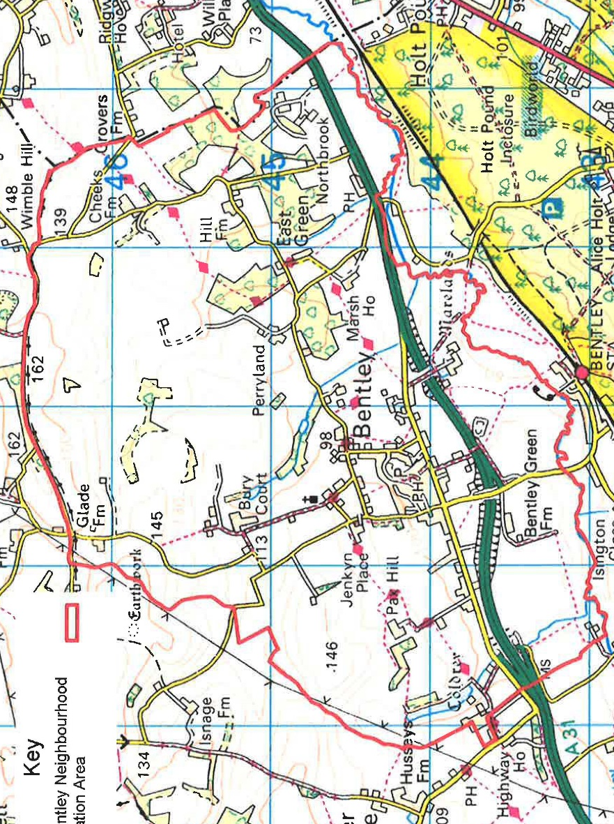
Crown Copyright Reserved LC 100024238-2014 East Hampshire District Council

Plan A: The Designated Bentley Parish Neighbourhood Area

Sustainability Appraisal (& Strategic Environmental Assessment)

1.4 The Parish Council has prepared a Strategic Environmental Assessment (SEA) Screening Report, in relation to the modifications, to establish whether an SEA will be required under the Environmental Assessment of Plans & Programmes Regulations 2004 (as amended). The statutory bodies, the Environment Agency, Historic England and Natural England, were consulted and confirmed their agreement that the modifications are unlikely to result in any significant environmental effects in June 2023.

1.5 A copy of the Strategic Environmental Assessment (SEA) Screening Report is available in Appendix M (An appendix to the Consultation Statement).

Habitats Regulations

1.6 The screening determination also confirmed that a Habitats Regulation Assessment (HRA) of the modifications would not be required in accordance with the Conservation of Habitats and Species Regulations (2017) (as amended).

The Next Steps

1.7 The Parish Council has reviewed the comments made at the Regulation 14 stage and , assessed where amendments were required. As a result a final Modified version of the Plan is now prepared for submission to EHDC for a further consultation and to arrange for its examination by an independent examiner.

2. Background Information and Evidence Base

Background

Location

2.1 The village of Bentley lies on the eastern edge of Hampshire, midway between Alton to the west and Farnham to the east. The river Wey forms the southern boundary to the village and in the north the Greensand ridge, between Well and Farnham, is the limit of the parish. It is bounded by the parishes of Crondall, Binsted and Froyle and the Borough of Waverley.

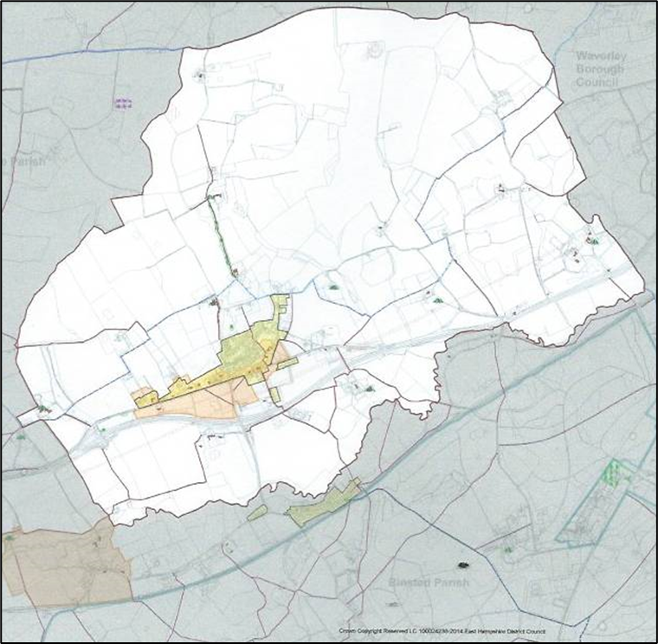
Plan B: Parish and Settlement boundaries – Bentley

Layout

2.2 The core of the village lies along the old A31 (Main Road) and is divided into four quadrants by the crossroads at the Memorial Hall. Much of the village falls inside the settlement policy boundary (SPB) which contains 367 houses. A further 137 houses are spread across the rest of the parish, some of these, although outside the SPB, are recognisably part of the village; properties east of the Recreation Ground for example.

2.3 The quadrants are as follows:
- The north east quadrant comprises shops, a public house, several small industrial units, offices, the school and recreation ground.
- The south east quadrant comprises some established well-spaced housing, industrial units and new housing located opposite the shops with some further recent housing opposite the Recreation Ground.
- The south west quadrant is mainly open fields.
- The north west quadrant includes the old village surgery and is fronted along the main road by cottages and several listed dwellings with further recent housing beyond.

Bentley History

2.4 The history of Bentley can be traced back to a Saxon clearing of part of Alice Holt forest following extensive Roman activity in the surrounding area. Various Saxon charters, from the 7th to the 10th Centuries, mention Bentley as having 10 hides of land, part of 60 hides of land in Farnham. The manor of Bentley was granted to the Bishop of Winchester, confirmed by the 9th Century. Reference to Bentley in the Domesday Book (1086) is as part of the 60 hides of Farnham. Hops became an important crop in the area after being first planted in the 1600s. The settlement evolved in two parts; one on the higher ground to the north around the 12th Century church of St Mary’s which was originally one of four chapels dependent on Farnham, and the main settlement along the London to Winchester coaching route on the flatter ground above the River Wey. The land between the two parts, made up of fields and pockets of woodland has remained remarkably intact (ref: Neighbourhood Character Study for EHDC, Dec 2018) preserving a rural edge to the northern side of the main settlement.

2.5 Until the end of the 19th Century, Bentley was a typical rural community with several farms supporting most of the population. Some residents, mainly females, were in service in the larger houses. Early commercial development was along the main road linking London with Winchester. This included a garage and a transport business. A shop and three public houses were also part of the village.

2.6 Farming has historically been mixed arable and livestock. In the 1960’s and 70’s most farms in the parish grew hops on the favourable soils developed over the Greensand to the north of the old A31. But the business declined and the last hop was picked in the parish in 2002. The sites of the hop gardens can be identified from the poplar trees that originally formed windbreaks around the sites. The oast houses, now converted to residential use, occur throughout the parish and three small vineyards have replaced some of the hops at Jenkyn Place.

2.7 Whilst the 2,299 acres of farmed land in the parish is largely unchanged there has been greater mechanisation of farming. The area of grassland and the stock numbers reduced in the 1970s in response to the surge of cereal cropping throughout the country. Today there is

one working farm with the bulk of the land worked under contracted schemes and only a handful of people working on the land compared with more than 30 in 1980.

2.8 The original village school, otherwise known as a “house of industry” where pupils were employed to knit gloves and stockings, was established is 1802. Following a donation of land from the Bishop of Winchester, a more formal educational establishment was built in 1842. Bentley school opened as a church school in 1843 and today is a successful Church of
England Primary school with approximately 210 pupils on the register compared with 115 in 1882.

The Human Character of Bentley

2.9 The image of the archer, seen on the village signs, has become associated with the parish. There has been some confusion as to his identity. It was commonly thought that he was William the Archer mentioned in the Domesday Book. However, William the Archer was, in fact, the tenant in chief of much smaller lands in Mottisfont, near Romsey, also known as Bentley. The identity of our Bentley archer is unknown.

2.10 A large stone tablet listing the names of the fallen in both World Wars, together with a sword made by a local blacksmith, fronts the Memorial Hall. The hall is a focal point for the many village activities together with the Recreation Ground and Pond. The residents of the village have created the ethos and made the village what it is; a country village.

2.11 Lord Baden Powell purchased Pax Hill in 1919 where he and his wife lived for 20 years. He established the Scout Movement and for many years camps were held in the grounds of the house. In 1920 he and the village school headmaster designed the village sign and the Bentley Book.

2.12 Viscount Montgomery, who lived at Isington Mill, was a well known figure in the village. Many families such as the Eggars, Harraps, Holmes, Joys, Pikes, Powells, Sherfields and Wheatleys demonstrate the importance of dynastic links and a determination to stay in and contribute to the welfare and development of the community. The Wheatley family came from the East End of London originally as hop pickers and stayed to build up the shop and support the village cricket.

Bentley Conservation Area Character Appraisal

2.13 Bentley Conservation Area was first designated in 1968. It was extended in January 1978 and then further extended in June 1993. Bentley By-Pass was built and opened in 1995. A further extension to the Conservation Area was approved and added in 2011. This incorporated 5 marked viewpoints to take in and maintain the village’s important southerly views, and to maintain views into and out of the Conservation Area. The map from the updated Bentley Conservation Area Character Appraisal and Management Plan (2014) is shown in Plan C and includes the added viewpoints and the extension to the Conservation Area.

2.14 The southern, eastern and western approaches to the village retain its strong rural character with views to the surrounding countryside, particularly the ancient woodland of Alice Holt Forest to the south and the Downs beyond. The northern approach is through

farmland and along the sunken Hole Lane, which is as visually interesting as the other approaches to the village.

2.15 The original boundary of the Bentley Conservation area largely followed the historic linear development along the old main road and mostly follows the settlement boundary along this axis. The majority of buildings are to the north of this road and many of the properties have listed status, 59 in total of which three are Grade II, including one the oldest houses in Hampshire. Other buildings are also of some historic or architectural interest such as stone barns, tombs and stone and brick walls.

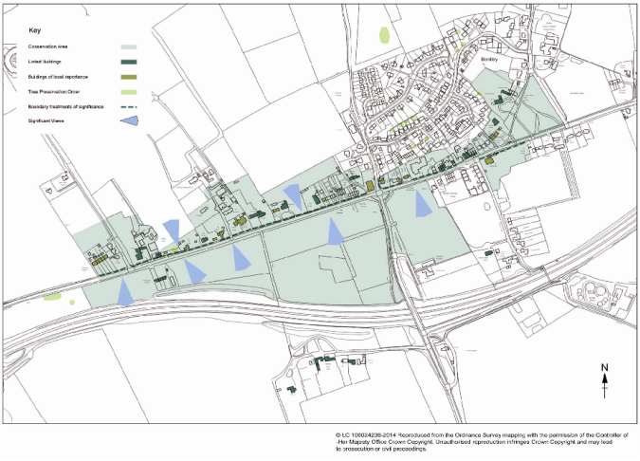

Plan C: Bentley Conservation Area - Character Area Map

2.16 Bentley has several archaeological remains including:
(a) Anglo Saxon structures and a shallow bronze-age pit at Bentley Green Farm;

(b) A medieval motte and bailey castle excavated in 1979 in the north of the parish.

(c) A medieval graveyard and two post medieval vaults found at St Mary’s Church.

2.17 The aim of the Conservation Area is to conserve and enhance the important character of the village along with its historic buildings, to deter additions which do not reflect traditional design and to discourage the use of materials that are not characteristic of the local area in any additions made to the existing housing stock. It is important that if any housing developments were to be made either in, or in close proximity to, the Conservation Area that

they reflect the clear premise and aims of the conservation designation and maintain and respect the viewpoints and other key characteristics.

2.18 The southern side of the old A31 has very few houses within the Conservation Area other than Crocks Farm Cottages to the western end of the village all with significant Grade II listed features and the Old Rectory in the middle of the village.

2.19 Built Heritage: In general, buildings in the parish use a specific range of materials including red/orangey toned local brick, and clay roof tiles (also used in tile hanging), local
Malmstone (a soft lime mudstone), ironstone, and a small amount of flint. Many of the buildings are timber framed concealed by brick or local stone.

2.20 The BPNP incorporates the Bentley Conservation Area, Character Appraisal and Management Plan, EHDC, Aug 2014, in its Design Policy, BEN3, to support recommendations for the design of the new development in the parish.

Community

2.21 The village has a strong identity with an active Parish Council. A variety of social and activity groups, and societies cater for all ages, but there are few activities for teenagers and a lack of formal support for the elderly and house-bound. The creation and management of social venues and activities is a continuing challenge but some like the scouts and cubs flourish, to the point of having waiting lists for entry. Further provisions are:

- Community bus service between Bentley, Alton and Medstead

- A hospital transport service provided by the local volunteer Care Group

- Dottie Tots nursery school

- Bentley Scouts, Cubs, Beavers and Squirrels

- Garden Club

- Annual Fete and Flower Show, annual bonfire and firework display

- Fitness and dance classes, aikido, badminton and table tennis clubs

- Fly-fishing club on the River Wey

- Women’s Phoenix Group

- Bentley Archers Cricket and Sports Club (newly formed, affiliated to Hants County Cricket and the ECB)

- Bentley Cycling Club

Amenities

2.22 Bentley is 4 miles of both Farnham and Alton, which have most shopping and cultural facilities, good secondary schools and sixth form colleges. The village has the following amenities:

- Memorial Hall, which houses the nursery school on weekdays; a thriving church with a newly built hall; the recently improved Bentley Primary School with a modern hall; and two nursing homes. However, the excellent school has a PAN of 30 (a single class intake) and is very popular. The catchment area extends to the parish of Froyle and takes in part of neighbouring Binsted.
- Village shop with a Post Office and a public house, The Star.
- Recreation ground (available to outside users) with pavilion, football pitch, artificial cricket pitch, cricket nets and children’s playground.
- Allotments, currently with a waiting list.
- Full range of utilities but the infrastructure is stretched, for example:

- Power cuts occur with a typical frequency for a rural village with much of the power provided via overhead lines.
- Water pressure can be significantly reduced at times of peak usage, particularly to the properties on the higher ground to the north of the village, some of whom experience complete loss of water at times.
- Sewerage capacity is insufficient causing episodes of raw sewage discharging into the River Wey
- Broadband is slow

- There is an extensive network of footpaths and Bentley is a popular centre for cycling.

Population and Housing

2.23 There are currently 504 dwellings in the parish, supporting a population of 1400 (2021 National Census parish level data set).

Category | Bentley | EHDC | Bentley % | EHDC %
Aged 0 to 4 | 78 | 6034 | 5.6 | 4.8
Aged 5 to 9 | 92 | 6914 | 6.6 | 5.5
Aged 10 to 14 | 97 | 7542 | 6.9 | 6
Aged 15 to 19 | 60 | 6788 | 4.3 | 5.4
Aged 20 to 24 | 43 | 5405 | 3.1 | 4.3
Aged 25 to 29 | 64 | 6159 | 4.6 | 4.9
Aged 30 to 34 | 56 | 6788 | 4.1 | 5.4
Aged 35 to 39 | 69 | 6914 | 4.9 | 5.5
Aged 40 to 44 | 99 | 7542 | 7.1 | 6
Aged 45 to 49 | 97 | 8421 | 6.9 | 6.7
Aged 50 to 54 | 95 | 9679 | 6.8 | 7.7
Aged 55 to 59 | 118 | 9805 | 8.4 | 7.8
Aged 60 to 64 | 83 | 8673 | 5.9 | 6.9
Aged 65 to 69 | 71 | 7291 | 5.1 | 5.8
Aged 70 to 74 | 67 | 7668 | 4.8 | 6.1
Aged 75 to 79 | 49 | 5908 | 3.5 | 4.7
Aged 80 to 84 | 62 | 4148 | 4.4 | 3.3
Aged 85 and over | 100 | 4021 | 7.2 | 3.2
Category | 1400 | 125700

Table A: Population age distribution compared to East Hampshire District (2021 census)

Employment

2.24 The village has two business parks with three garages, a golf club supply and metal fabrication businesses and warehousing for office supplies. There are also offices blocks holding consultancy and accountancy businesses.

2.25 The 2021 Census found that 55.9 per cent of the village population is employed (Table B). The significant difference between Bentley and East Hampshire District is attributable to Bentley residents being mainly in more qualified and probably higher paid positions.

Category | Bentley | EHDC
In Employment | 783 | 74792
1. Managers, directors and senior officials | 157 | 13238
2. Professional occupations | 194 | 15931
3. Associate professional and technical occupations | 132 | 10546
4. Administrative and secretarial occupations | 50 | 6955
5. Skilled trades occupations | 91 | 8451
6. Caring, leisure and other service occupations | 65 | 7031
7. Sales and customer service occupations | 30 | 4264
8. Process, plant and machine operatives | 19 | 3141

Table B: Population and Employment (2021 census)

2.26 46% of the working population work from home (Table C), this compares to 12% in the 2011 Census; fewer than 10 per cent travel by train to work, whilst nearly half drive to work. A small number less than 1% use the bus and 3.5% use either cycles or walk to their places of employment.

Transport

2.27 There are good road links to surrounding towns, the M3 and A3, but narrow roads, characteristic of a village, cause congestion. The Village undertook a traffic survey in October 2018 at the crossroads next to the Memorial Hall. This update of a survey performed in July 2012 showed that traffic has increased on average by 2.7% per annum. The traffic comes predominantly from the south and turns eastward through the centre of the village. However, the traffic from and to the north has increased significantly since the last survey. Unless there are changes to the road layout the volume and noise of the traffic may be unacceptably increased by more housing and commercial development in nearby settlements, particularly Froyle. The increase in traffic from the southern approach suggests
that many more vehicle movements at the cross-roads could occur as the Whitehill Bordon Eco-Town development (referred to in the Whitehill – Bordon Eco-Town Traffic Management Strategy) continues to grow. The development plans for 3350 dwellings to be built over the next 12 years.

2.28 An increase in traffic can be attributed to the limited access points to the by-pass when it was constructed which has led to an increase in traffic through the village: the high percentage of traffic coming from the south along River Road, and turning eastwards at the crossroads to join the A31 in the Farnham direction; westbound traffic turning off the by-pass and turning west at the crossroads; eastbound traffic from the Froyle direction that continues through the village to the eastbound A31. The solution may be to create an eastward link to the by-pass at the Coldrey junction and both eastward and westward links at the bridge over the bypass in River Road. However, whilst uncosted, indicatively this may need significant funding and land acquisition.

2.29 Parking at the station, school and shop is already woefully inadequate and dangerous.

2.30 The mainline railway station provides a good service with regular, direct trains to London Waterloo. The bus service to Guildford and Winchester is adequate during the day but poor in the evening.

2.31 For the more energetic there is a good footpath network for short and long distance walking but no complete cycle path to Farnham or Alton.

Category | Bentley | EHDC | Bentley % | EHDC %
Work mainly at or from home | 360 | 28047 | 46 | 37.5
Underground, metro, light rail, tram | 0 | 0 | NA | NA
Train | 13 | 823 | 1.6 | 1.1
Bus, minibus or coach | 2 | 524 | 0.2 | 0.7
Taxi | 0 | 150 | NA | 0.2
Motorcycle, scooter or moped | 2 | 299 | 0.3 | 0.4
Driving a car or van | 359 | 36798 | 45.9 | 49.2
Passenger in a car or van | 10 | 2393 | 1.3 | 3.2
Bicycle | 4 | 598 | 0.5 | 0.8
On foot | 23 | 4488 | 3 | 6
Other method of travel to work | 10 | 672 | 1.3 | 0.9
 | 783 | 74792

Table C: Work travel, (National Census 2021)

Housing and Development

2.32 Much of the current village housing stock has been built after the Second World War. Babs Field was developed as a council estate in the late 1940’s and since then there has been the steady addition of a variety of housing, with 293 dwellings added to the village (Table D).

Location | Number | Date | Comment
Bab’s Field | 43* | 1940’s | Council estate, now partly privately owned
Main Road (Police House) | 1 | 1940's | Privately owned
Oakway & Main Road | 6 | 1960’s | Privately owned
School Lane | 2 | 1960's | Privately owned
Main Road (centre) | 8 | 1970's | Privately owned
School Lane | 2 | 1970's | Privately owned
Eggars Field (1) | 34 | 1980’s | Privately owned
Rectory Lane | 3 | 1980's | Privately owned
Pax Hill (Lodge etc.) | 3 | 1980's | Privately owned
Eggars Field (2) | 15 | 1990’s
Broadlands Close | 28 | 1990’s
Bonner’s Field | 38 | 1990’s
Main Road (opposite playing field) | 3 | 1990’s
Longcroft | 19 | 1990’s
Main Road (west) | 2 | 1990's
Hole Lane | 3 | 1990's
Main Road (centre of village and western end | 10 | 2000’s
Eggars Field | 3 | 2013 | Privately owned (1 pre 40s demolished replaced by 3)
Hole Lane (next to surgery) | 1 | 2014 | Privately owned
Holmes Field Court | 9 | 2014 | Privately owned
School Lane | 2 | 2015-17 | Privately owned
Oakway & Hole Lane | 2 | 2015 | Privately owned
Somerset Field | 37 | 2016 | Private & housing assoc.
Westport House | 4 | 2016 | Privately owned, conversion of office units into flats
Main Road (Ind. Est.) | 8 | 2018 | Privately owned
Main Road (opposite playing field) | 5 | 2018 | Privately owned
School Lane | 1 | 2018 | Privately owned
Eggars Field | 1 | 2023 | Privately owned
Total | 293
Table D – Houses erected since WWII

*Originally 54 houses were built on Babs Field. However, 11 were demolished and replaced during the building of the adjacent Longcroft.

2.33 After the Babs Field construction, up until the 1980’s, house building was minimal but since then substantial additions have been made to the village.

2.34 Policy CP10 of the JCS set a number for the ‘other villages outside the National Park’ of a minimum of 150 dwellings to be provided in the plan period of 2013-2028. Bentley parish has absorbed several developments during this period: Holmes Field Court, 9 dwellings; Somerset Field, 37 dwellings; East Field (Main Road) 5 dwellings; Trimmings Close (Main Road, Ind. Est.) 8 dwellings, as well as a number of smaller in-fill developments. In addition, from 2005 there has been a Gypsy and Traveller site located near the water treatment plant, The Paddocks, Vickery Lane, which is now 8 pitches and associated buildings. In total 72 permanent dwellings have been added since April 2013, which is a more than adequate number for the size of the village with constrained community facilities and services, for example with the closure of the village surgery residents must now travel at least to Alton or Chawton to visit their GP.

2.35 It is noted that the emerging EHDC Local Plan Regulation 14 (Part 2) (2024) has made a single site allocation for a maximum of 20 homes in Bentley.

2.36 The village is a favoured site and the price of housing is above the county average. The placement of the school high up in the National Tables of excellence has put pressure and value upon properties in the settlement with many of the smaller, recently developed houses, being purchased on a buy to let basis. This has effectively raised the value of properties and has created a changing housing ownership/occupation pattern.

Adjacent Villages

2.37 Development in adjacent villages/towns that will have an impact on Bentley:

Froyle

2.38 Froyle is a small village approximately 2 miles west of Bentley divided into two areas; Upper and Lower Froyle. It has very limited local services and many residents rely on the services provided in and around Bentley for their day to day needs including, but not limited to, Bentley Primary School, Post Office and Bentley Station.

2.39 In Upper Froyle, the former Treloars College is still in the process of being re-developed. There are now 90 dwellings on the site, 86 of which are new.

2.40 There is an increased demand for services in Bentley from new residents in Froyle for which it will take some time to adjust and absorb. The anticipated increase in traffic from Froyle has already been observed (Bentley Traffic Survey, 2018).

Whitehill & Bordon

2.41 Whitehill & Bordon is located approximately 6 miles south of Bentley. There will be adequate local services, but no railway station.

2.42 As part of a new Whitehill & Bordon initiative, East Hampshire District Council has granted permissions for approximately 4000 new dwellings, the majority of which will be built

between 2015 and 2028. After over 100 years as a ‘garrison town’ and following the Army’s departure in December 2015, over 100 hectares were released for building. The population of the town is predicted to increase by 7000.

2.43 Whitehill-Bordon Eco-Town Traffic Management Transport Strategy 2012 (TMS).
The TMS will incur a major increase in traffic wishing to avoid the A325. Some of this will use the Frith End and Blacknest Roads to go to Bentley Station. Even more will continue up River Road to access the A31 by travelling East or West along the Main Road through
Bentley. The 2018 Bentley Traffic Survey has already provided evidence of the increase in traffic from the South into Bentley.

2.44 The TMS contains costed proposals to

(i) introduce traffic calming measures such as enhanced village gateways, pinch-points and chicanes along the Frith End, Blacknest and River Roads;

(ii) extend the 30mph limit on the Main Road to the west of Bentley;

(iii) create a single-lane scheme through the Village centre between the Bentley cross-roads and School Lane. This could include pinch-points at either end, passing points and widened footways.

Health

2.45 Following the closure of the NHS General Practice in the village in 2022, residents have been assigned to several practices in and around Alton.

2.46 Bentley Lodge and Pax Hill nursing homes provide permanent residence for approximately 140 people. Pax Hill also holds rooms for short-term family respite. A volunteer care group provides health related transport services in the village.

Community views

2.47 As part of the development of the BPNP a number of ways of gauging opinions have been established. These have included:

(i) Two consultation events, which were held at the Memorial Hall in November 2018 at the start of this review process. These events included an opportunity for residents to comment on the themes defined in this background section and to listen to presentations and ask questions about the neighbourhood plan role and process. Residents also took part in a SWOT (Strengths, Weaknesses, Opportunities and Threats) exercise. A summary of the SWOT feedback is available in Appendix H.

(ii) A survey questionnaire, which was delivered to every household in the parish in November 2018 to obtain views on the themes defined in this background section. A copy of the original questionnaire is available in Appendix F and a summary of the findings is available in Appendix G.

2.48 A summary of the key themes is as follows:

a. Housing
- 87% of survey respondents think it is very important for “new building to be sympathetic to the scale & density of existing buildings”;
- The vast majority of respondents feel that “anything more that groups of 6 houses will spoil the village” (a marked preference for infill and up to 5 houses);
- Some issues raised are that there has been unwanted “Building outside the settlement boundary”, that development should “maintain linear development only”, the “Village harmed by poorly designed and large scale housing development” and that “Increased development putting pressure on village infrastructure”

b. Traffic
- 64% of questionnaire respondents say that “the increase in traffic in the village is unacceptable” and 81% of respondents think that “the speed of traffic through Bentley is unacceptable”;
- The top 2 concerns of respondents are – “loss of countryside, increase in traffic”;
- Other issues raised are the “Increase in traffic at crossroads and through the village due to “rat runs” and the impact of “Increased development in nearby towns e.g. Bordon leading to more traffic through the village”
- A solution suggested is to “Build slip road onto A31 at the bridge”

c. Parking
- 51% think that “the level of on-street parking is unacceptable and that more should be done at school drop-off and pick-up times” and that “School parking a nightmare” as are the “number of cars parked in the road near crossroads and the shop”

d. Flooding
- Residents commented on “Poor drainage leading to flooding” and 20% of respondents have “experienced damage due to poor drainage/flooding”

e. Types of housing
- “Small detached and a traditional style” are the most preferred new housing types;
- Only 7% of respondents report that “someone has had to move out of Bentley due to lack of housing”, however there is a view that we should “Encourage more affordable development”;
- Some residents say that “Too many executive type houses and not enough that is affordable to many people or for those wishing to downsize”;
- Residents also say that they would prefer “To have sympathetically designed small development”, they comment on the “Lack of house design criteria” and that “New housing must blend with the older houses in the village”

f. Village character and views
- Residents commented on the “Characterful village”, “Rural setting, surrounded by countryside” and 98% of questionnaire respondents think that “Bentley has a historic and rural feel”;
- There is a feeling that there has been an “Erosion of views” and that we should “Protect views of the village e.g. from the south”;
- Another issue raised is the “Erosion of historic design & feel of village by building poorly designed houses”;
- In 15 years time, respondents would most like the village described as – “community feel, safe, friendly, attractive, tranquil”;

g. Footpaths and cycling
- Residents report a “Good network of footpaths”;
- Improvements suggested are “Better footpaths in lanes” and a “Cycle path between the village and station”

h. Community
- Residents report the top 3 important reasons for living in Bentley are – “the rural aspect, village community and the village events e.g. the fete” and that there is a “Strong sense of community and spirit”

2.49 The above themes as well as other comments received from the SWOT exercise and questionnaire have been use to influence the modifications made to our Neighbourhood Plan, especially the policies.

3. Planning Policy Context

3.1 The Parish is part of East Hampshire District in the County of Hampshire. East Hampshire District Council has policies and proposals that have a significant influence over the strategy and detailed content of the BPNP.

3.2 The National Planning Policy Framework (NPPF) published by the Government in 2012 ( last updated December 2023) is also an important guide in the preparation of local plans and neighbourhood development plans. The BPNP must demonstrate that it is consistent with the provisions of the NPPF.

3.3 The Modified Plan must be in ‘general conformity’ with the strategic policies of the development plan, for East Hampshire this comprises the Local Plan Part 1 – Joint Core Strategy, Local Plan Part 2 – Housing and Employment Allocations, the Saved Policies of the East Hampshire District Local Plan: Second Review and the Hampshire Minerals and Waste Plan.

The Local Plan Part 1 – Joint Core Strategy (2014)

3.4 The Core Strategy sets out the spatial plan until 2028 for East Hampshire and the part of South Downs National Park that fall within East Hampshire. The plan has divided the district into four geographical areas, Bentley is situated to the North of the South Downs National Park area. As such Bentley along with the other settlements in this area, only need to sustain their current role through providing some commercial and community uses.

3.5 The CP2 Spatial Strategy policy sets out a settlement hierarchy for the district and Bentley has been identified as Level 4- Other Settlements with a settlement policy boundary. This means that Bentley may be appropriate for further small scale development within the settlement policy boundary.

3.6 The CP10 Spatial Strategy for Housing sets out the minimum number of new dwellings to be developed in each of the levels in the settlement hierarchy. Bentley is one of the twenty settlements referred to as “other villages outside the National Park” that should together provide a minimum of 150 dwellings.

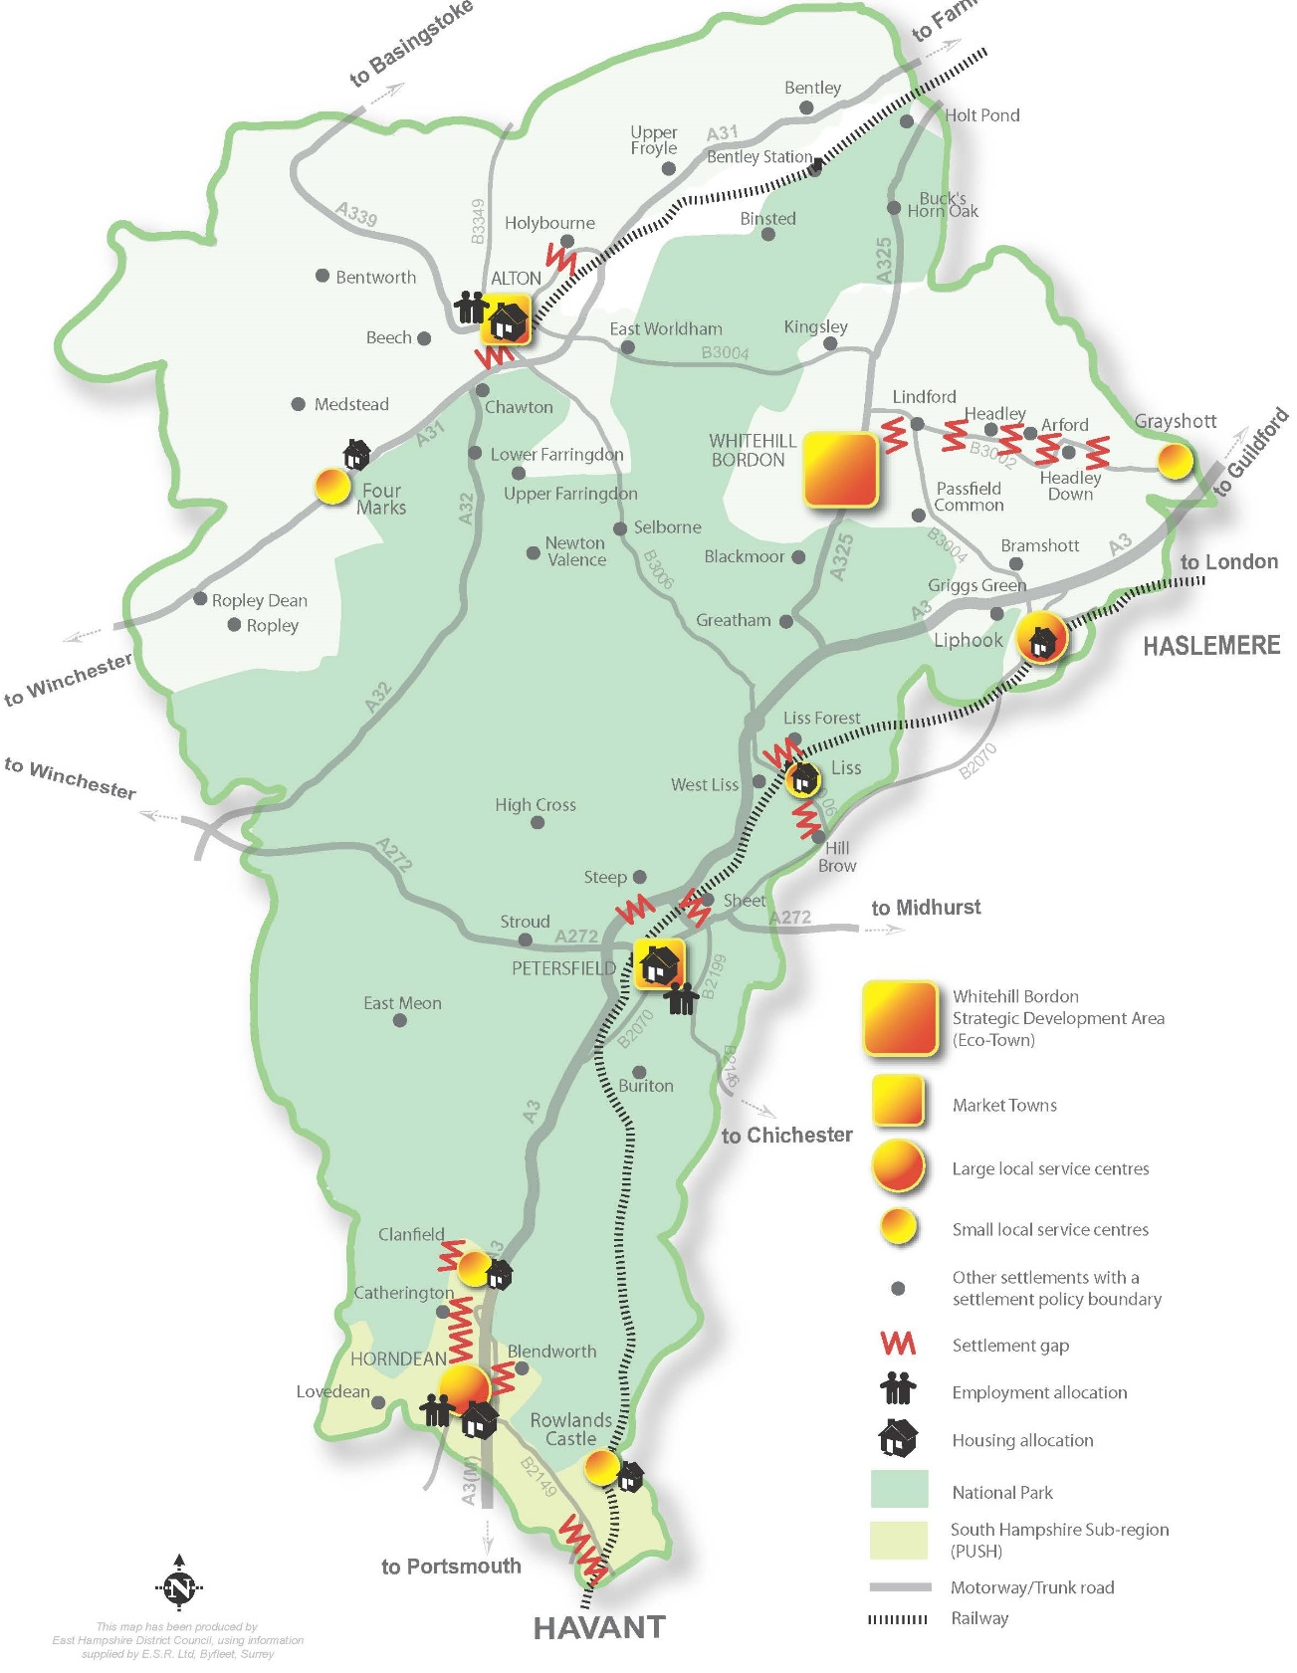

Plan D: East Hampshire Local Plan, Core Strategy - Key Diagram

3.7 Further strategic policies of the East Hampshire Core Strategy that sets the policy framework for all the neighbourhood plans in the District are the following:

CP2: Spatial strategy
CP4: Existing employment land
CP6: Rural economy and enterprise
CP8: Town and village facilities and services
CP16: Protection and provision of social infrastructure
CP17: Protection of open space, sport and recreation and built facilities
CP18: Provision of open space, sport and recreation and built facilities
CP21: Biodiversity
CP23: Gaps between settlements
CP26: Water resources/water quality
CP28: Green infrastructure
CP29: Design
CP30: Historic environment
CP31: Transport

3.8 Alongside a small number of saved policies from the Local Plan Second Review 2006, which have been retained, these policies provide the framework, within which the general conformity of the BPNP with the development plan will be assessed. The BPNP should not however repeat what the district plan is saying but add local land use policies.

The Local Plan Part 2 – Housing and Employment Allocations

3.9 As part of the work towards the Local Plan part 2, EHDC consulted the towns and villages in the district and the final document was adopted in April 2016. The main aim of the part 2 document was to allocate sites for both housing and employment development in the district. Adopted Neighbourhood Plans work as site allocation plans for their specific plan area and hold the same weight as the Local Plan. Parishes in the district who were not producing a Neighbourhood Plan still had an opportunity to engage their community through the EHDC’s Local Interim Planning Statement (LIPS) that formed part of the evidence towards the Local Plan part 2.

3.10 Many of the saved policies in the East Hampshire District Local Plan: Second Review have been superseded by policies in the Local Plan – Joint Core Strategy. The remaining ‘saved’ policies continues to be used in determining planning application until they are replaced by policies in the emerging Local Plan.

The Bentley Plan (2014)

3.11 Bentley Parish Council has undertaken the work of consulting, analysing and producing the Bentley Plan (2014). This document was prepared to inform the work of the East Hampshire District Local Plan Part 2 in preparing the Local Interim Planning Statement (LIPS) for Bentley Parish and was completed in August 2014.

3.12 At the time of preparing the Bentley Plan there were several planning applications for small to medium sized developments in Bentley Parish. The Bentley Plan was prepared in the hope and expectation that it would be used by East Hampshire District Council to assess these planning applications.

3.13 The Bentley Plan contained the following elements:

- A Vision that reflected the particular physical character and qualities of the village including its setting, landscape and heritage assets;
- Development Criteria for assessing any proposals for development within Bentley, including the location, scale and rate of development, the character of development and infrastructure needed to support such development;
- Key Principles for assessing such development proposals; and
- A map to show the location of the protected rural edge and open views, (referred to in the Development Criteria and Key Principles).
3.14 By indicating a protected rural edge to the north of the built up part of Bentley Parish, it was anticipated that some development may be appropriate within this area, but the Bentley Plan did not allocate sites for such development.

3.15 The Bentley Plan and its Vision, Development Criteria and Key Principles were widely supported by Bentley residents (see original Consultation Statement).

3.16 Following completion of the Bentley Plan, outline planning permission was granted for 37 dwellings (55417/001 referred to in paragraph 4.15 below) on one site to the west of Hole Lane (“Permitted Site”). Permission for this development was granted in accordance with East Hampshire District Council’s Interim Housing Policy Statement 2014. This development in its scale and location did not comply with the Vision, Development Criteria or Key Principles contained in the Bentley Plan and referred to above. In particular it did not comply with the following Key Principles:

- A few smaller developments instead of one large development; and
- Developments should be at a scale of 8 – 12 dwellings in separate pockets connected to the village.
3.17 Consequently, the BPNP took into account the additional dwellings to be constructed on the Permitted Somerset Field site, and the 9 additional dwellings built on Crocks Farm. The BPNP has therefore only identified one additional site for development in Bentley Parish (rather than the several smaller sites anticipated in the Bentley Plan). This is because CP10 Spatial Strategy for Housing (referred to in paragraph 3.7 above) requires a minimum number of 150 dwellings to be developed in total in the twenty settlements referred to as “other villages outside the National Park”. By identifying one other site for development the BPNP will allocate sites for up to 56 dwellings (37% of this total figure).

3.18 The Vision, Development Criteria and Key Principles set out in the Bentley Plan have (as far as possible) been incorporated in the BPNP, and subsequently the Modified Plan.

The Emerging East Hampshire Local Plan

3.19 While the Modified Plan must be in general conformity with the strategic policies of the adopted Local Plan, it can also reflect the reasoning and evidence of the emerging East
Hampshire Local Plan. Parts of the evidence base have been drawn on and supplemented to inform the Modified Plan.

3.20 EHDC began reviewing its Local Plan in 2018. Two Regulation 18 consultations were held in 2019 including a larger sites consultation. A further Regulation 18 Issues and Opportunities consultation was carried out in December 2022 – January 2023 with a further Regulation 18 consultation between 22nd January and 8th March 2024. The Regulation 18 (2024) identifies a need for a minimum number of 9,082 dwellings over the plan period (2021- 2040). As of 31st March 2023 part of this minimum requirement was already made up of 940 net completions and existing planning permissions totalling 3,965 new homes, with a windfall allowance of 1,320, leaving a requirement for a further minimum of 2,857 new homes. The emerging Plan seeks to allocate 3,500 homes and makes a single allocation for 20 homes in Bentley as a lower tier settlement.

4. Vision, Objectives and Land Use Planning Policies

The Vision

The Vision for Bentley Parish

4.1 This vision reflects the particular physical character and qualities of the village, including its setting, landscape and heritage assets, as well as the cultural and community assets that have been identified as being of value and importance. The vision for Bentley in 2028 is;

“Bentley will have retained its character and identity as a rural village with a strong sense of community and strengthened its relationship to its landscape setting through the careful siting of development to maintain views and the character of the rural lanes, and the development of new open spaces and community amenities.

Community facilities will have developed to meet the changing needs of residents, with a new pavilion on the Recreation Ground. Reflecting the recent increase in interest in cricket and football in the parish, the playing surface will be improved and include the installation of a new cricket square. The parish will also have taken a greater role in the ownership and management of these facilities along with the parish’s other natural assets leading to benefits for pedestrians and cyclists through improved connectivity and additions to the network of footpaths, bridleways and public rights of way.

The parish will have a strong, positive and supportive relationship with local employment and businesses helping facilitate new employment opportunities for local people and supporting shops and businesses, creating a thriving village centre.

Traffic and parking impacts generated locally and through development outside the parish will have been managed and controlled through a positive working relationship with the district council and county highways, and through the implementation of local traffic management schemes.

There will have been a modest growth in housing numbers through the provision of new homes, purpose designed to meet local needs including elderly downsizers, and to provide a balance of dwelling types to serve the community over the long term. These new homes will have been provided in small clusters on sites that do not detract from the character and setting of the parish.”

Objectives & Measures

4.2 To achieve this vision a number of key objectives have been identified, these are:

- Growth will be achieved through a few, smaller developments rather than one or more large development.
- Developments will meet local needs, in particular for local elderly downsizers.
- Connections to the village will be integrated with the existing network of rural lanes, bridleways and footpaths to improve and extend safe pedestrian and cycling routes and to minimise traffic generation.
- Each development pocket will include a landscape setting that creates an appropriate and attractive rural edge to the village.
- The existing rural character of the edge of the settlement is to be protected and enhanced.
- The setting and character of Toad Hole Lane is to be protected.
- Open views southwards towards the South Downs are to be preserved.
- The Special interest of the Conservation Area and the significance of listed building, and the settings of both, are to be protected and, where possible enhanced.
- Provision will be made for additional community services and amenities to support a wider range of parish needs and reinforce the identity and purpose of the village centre.
- Local green spaces will be protected and opportunities for improving biodiversity identified. These spaces will be integrated with the pedestrian and cycle network.
- Any development should contribute to the community infrastructure needs identified by the parish.

4.3 The BPNP has assessed its objectives to be compatible with the principles of sustainable development. There are some strong, positive impacts in respect of providing for new homes to meet local need and of protecting the landscape and community services of the parish. The District Council’s Sustainability Appraisal for its Part 2 Plan identified no likely negative effects on the BPNP pursuing these objectives.

Monitoring & Review

4.4 The Modified Plan will be monitored by the local planning authority and Bentley Parish Council on an annual basis as part of the East Hampshire District Annual Monitoring Reports. The objectives and measures will form the core of the monitoring activity but other data collected and reported at a parish level relevant to the Plan will also be included.

4.5 It is expected that the BPNP will be formally reviewed on a five-year cycle or to coincide with the review of the East Hampshire District Local Plan if this cycle as appropriate.

Policy Issues

4.6 The Planning policy context and the community engagement work already undertaken have raised a number of issues for the Neighbourhood Plan to address:

• What are the shared design characteristics of the area that could be included in a policy, should the Conservation Area Appraisal and the Management Plan be incorporated?

• What shape should the employment policy take in refining the existing protection policies?

• What community facilities would be on the list of those to be protected from a change of use?

• Which spaces meet the criteria for designation as Local Green Spaces? Do they already benefit from any type of protection and, if so, is there any additional value to a designation?

• What public footpaths, heritage routes cycle routes and bridleways already exist? Can these routes be improved to better connect the villages and the access to the countryside?

Land Use Policies

4.7 The BPNP contains a series of land use policies, the successful delivery of which during the plan period will help achieve the community’s vision for the parish.

4.8 It is not the purpose of the BPNP to contain all land use and development planning policy relating to the parish. Rather, it contains a series of policies that will be applied by East Hampshire District Council (EHDC), as the local planning authority, alongside other relevant policies of the Development Plan for East Hampshire and of the National Planning Policy Framework to determine planning applications. The silence of the BPNP on a policy matter does not therefore mean that the matter is not important in the parish but that the local community is satisfied that it will be addressed by other Development Plan policy.

4.9 In particular a Policy on Rural Exception Sites and Transport are contained within the EHDC Joint Core Strategy as Policies CP14 and CP31 respectively.

4.10 The local community wished to safeguard an employment site within the village in line with the EHDC Local Plan Second Review 2006. However, the site is currently subject to a Planning Appeal. Although this BPNP does not safeguard the site, if it remains in employment use a future review of the BPNP will look to include a safeguarding policy.

4.11 Each policy is numbered and there is a short explanation of the policy intent and its justification, together with an explanation of any assumptions or definition of terms. The evidence documentation is available either directly or via a link on the Parish Council’s website.

Policy BEN1: Spatial Plan

A. The Neighbourhood Plan designates a Bentley Settlement Boundary (BSB) as shown on the Policies Map and Appendix B. Development proposals within the BSB will be permitted provided it complies with the provisions of relevant policies.

B. Development outside the BSB will only be supported if it can demonstrate a genuine and proven need for a countryside location. Any development for “affordable housing for rural communities” in accordance with Policy CP14 of the Joint Core Strategy and / or meets the requirements of the East Hampshire SPD: Housing Outside Settlement Boundaries will only be supported if it is demonstrated that it will fill a genuine and proven local housing need

4.12 This policy establishes the key spatial priority for the BPNP and accords with §83 and §84 of the NPPF. It sets the direction for all its other policies by steering new development into the established settlement: Bentley village, by continuing to exert strong control over development proposals elsewhere in the countryside areas of the parish. Details of the amendments to the existing BSB are set out in Appendix B reflecting development which has already taken place.

4.13 The effect of the policy is to confine housing and other development proposals that accord with JCS policies CP6 and CP10 to within the BSB, unless they are appropriate to a countryside location in accordance with JCS Policy CP19. It is for an applicant to submit evidence to justify whether a site meets the criterion related to the policies. Whilst applying to all parts of the LPA area, the Parish Council considers it unlikely that the criteria set out in the adopted Housing Outside Settlement Boundaries SPD of March 2023 can be met at Bentley, and nor are the tests of JCS Policy CP14 in respect of affordable housing on land outside the BSB. It is acknowledged that EHDC as the decision maker will make any determination relating to this in relation to applications for Bentley.
4.14 The Parish Council considers that there are no over-riding community needs or aspirations for housing growth over the plan period to 2028 that would reinforce the village’s role and function as a lower tier settlement. As it is, Bentley has absorbed considerable residential development since 2013 with 72 new residential dwellings. This equates to a 17% increase and was partially justified in bolstering the demand for supporting infrastructure in Bentley. But instead, the village has lost two of its three retail businesses and its doctor’s surgery since the made Plan. Given trends in the provision of such local services, it is considered that new housing will not lead to their return to a village of this size, type and location. Furthermore, traffic flows have also increased (See The Bentley Traffic Survey 2018). It is noted that the emerging EHDC Local Plan Regulation 18 (part 2) (2024) allocates a development site for up to 20 new homes to the west of the recent development for 37 homes at Somerset Fields. Part of the site is also currently subject to a planning appeal for 12 homes.

4.15 The western, northern and eastern perimeters of Bentley have a distinct character in terms of its density and type of development, lanes, landscape and topography, with rising contours which have previously been identified as having landscape significance. The Bentley Plan recognised this, underpinned by the majority wish of residents.

Policy BEN2: Development Principles

New development should protect the character of the established settlement pattern of the village by having full regard to the following principles where relevant to its location, nature and scale:

- preserving open views across and along the valley, and towards the higher ground to the north;
- preserving the rural edge to the northern side of the main settlement;
- consolidating the existing linear layout by avoiding residential garden, backland or tandem development unless there is precedent in that specific part of the village;
- avoiding an adverse effect on the character and appearance of the locality, particularly if in or adjacent to the Conservation Area;
- ensuring the development is not harmful to the significance of designated Grade II listed buildings through the impact on their setting;
- ensuring the development is located to enable connections to the existing network of rural lanes, bridleways and footpaths to improve and extend safe pedestrian and cycling routes and to minimise traffic generation;
- ensuring the precise location, height and massing of the development avoids the potential for visual coalescence between the village and adjacent settlements such that the village does not lose its identity; and
- ensuring the size and orientation of each building plot, and its coverage, reflects the established pattern of plots within the immediate area, and where this allows for larger properties then ensuring they are arranged to provide an open, rural aspect.

4.16 This policy accords with the NPPF (Para’s 132 ,135 and 203) and policies CP29, CP30 and saved Policy HE12 of the EHDC Joint Core Strategy, in requiring the design of development proposals to reflect the local character of Bentley and especially of the significance of its designated heritage assets, i.e. the Conservation Area and listed buildings. This policy also accords with Section 66 of the Planning (Listed Buildings and Conservation Areas) Act 1990 requiring planning authorities, when considering whether to grant planning permission for development which affects a listed building or its setting, to have special regard to the desirability of preserving the building or its setting or any features of special architectural or historic interest which it possesses. The policy accords with Section 72 of the Planning (Listed Buildings and Conservation Areas) Act 1990 requiring planning authorities, when considering whether to grant planning permission for development which affects a Conservation Area, to have special regard to the desirability of preserving or enhancing the character and appearance of that area.

4.17 The traditional character of the settlement pattern should be preserved so that open views across and along the valley and towards the higher ground to the north are preserved. The open land between the early settlements of the main village and St. Mary’s Church (ref:
Neighbourhood Character Study for EHDC, Dec 2018) should be preserved to maintain a rural edge to the northern side of the main settlement. The predominantly linear form of the
settlements should be maintained rather than building any new estates or other developments that change the shape of the village or result in the creation of new public roads. Change should be small in character and thus it is important that incremental proposals that seek to circumvent proper scrutiny by artificially sub-dividing a larger site

with a well-defined, physical boundary and in the same ownership, are discouraged, and if applied for, refused.

4.18 In avoiding residential garden, backland or tandem development, new residential development within the settlement policy boundary should be confined to infilling, redevelopment of previously developed land and buildings, conversion, subdivision or change of use of buildings. The density of housing should always respect the surrounding properties to preserve the rural character of the parish.

4.19 Front boundaries on thoroughfare roads in Bentley tend to be hedged or walled or display a combination of both. This is essential to maintain privacy, security and the rural character of the village. Such that where any proposed development is adjacent to properties displaying front boundaries in this way, it is necessary that the same approach is adopted. New residential development must respect be sustainably connected to the village, consistent with the requirements of CP31 of the Joint Core Strategy.

4.20 The linear nature of Bentley village is an historic characteristic. Backland or tandem development should be discouraged, particularly if it is not in keeping with a specific area of the village. It is essential that any possible backland development complies with policy and does not risk overdevelopment, overlooking or overshadowing, loss of amenity or daylight to existing residents, harm to the character of the village, access and traffic problems or drainage issues.

The gaps between the various defined settlement policy boundaries should be preserved and protected from inappropriate development such that each settlement does not lose its identity. No industrial or commercial development that could lead to significant adverse impact on the rural character of the parish should be permitted.

4.21 EHDC has recently prepared a Conservation Area Appraisal and Management Plan for Bentley. This new document is an update to the older Appraisal and includes the new extension to the Bentley Conservation Area which was approved in 2012. The appraisal and the Management Plan inform decisions on future development proposals within the Area or that may affect its setting.

Policy BEN3: Design

New development should protect the established character and appearance of the village by having full regard to the following design principles where relevant to its location, nature and scale:

- Within the Bentley Conservation Area, demonstrating that the design guidance of the Bentley Conservation Area Appraisal has been acknowledged, understood and positively responded to in seeking to conserve and enhance its significance as a heritage asset;
- Within the setting of the Conservation Area, ensuring the development acknowledges the importance of the visual and/or functional relationship between the site and its significance as a heritage asset and seeks to conserve and enhance that significance;

- Outside the Conservation Area and its setting, ensuring the development reflects the rural character and landscape features of Bentley Parish;
- The features of the new dwellings should reflect the characteristics of neighbouring properties;
- Ensuring new dwellings are of no more than two storeys below the eaves level, with any habitable rooms in the roof space being lit by dormer windows or roof lights that complement but not dominate the roof;
- Ensuring that only vernacular building materials are used on the external faces of the building, unless it can be shown that modern equivalent materials are appropriate and will provide a similar visual appearance;
- Extensions and alterations to existing buildings (and new outbuildings) should:
a. reflect existing fenestration and design elements of the host dwelling;

b. be subservient to the host dwelling and reflect its appearance and taking into account the existing street scene;

c. sit comfortably with the existing building such that any awkward articulation is avoided;

d. where a side extension, allow for a visual break from a communal boundary to ensure separation from adjacent dwellings unless this is the established character of the local area;

e. where a roof extension, not significantly alter the pitch or profile of the existing roof, with any new rooflights and dormers being well-related to the existing fenestration and avoiding dominating the roof; and

f. where a new garage or outbuilding, respect and reflect the scale and character of the existing dwelling and any established building line, such that they do not dominate the front façade of the main property;

- boundary treatments should be designed in materials and details that reflect the street scene or local area; and
- new non-residential buildings to respect their built or rural context in terms of their design and relationship to adjoining or nearby buildings and /or landscape features

4.22 Policy CP29 of the EHDC Joint Core Strategy requires all new development to respect the character, identity and context of the District’s towns, villages and countryside, and requires new development to use exemplary standards of design and architecture with a high quality external appearance that respect the area’s particular characteristics. The Design of New Housing policy lays out the specific requirements for the design of new development in Bentley. The policy is informed by the Bentley Village Character Assessment Study, June 2023 and conforms to §132, §135 and §201 of the NPPF

4.23 The character of the built design of Bentley is strongly determined by the pre-war housing stock. This is predominantly of the Georgian and Victorian periods. Whilst not suggesting that designs from these periods should be replicated as architectural pastiche, there are a number of consistent design elements defining these buildings that should be carried into any new development, so that the continuity, identity and rural character of the parish, and especially the village, can be preserved.

4.24 Whereas it is desirable to differentiate individual dwellings in any new development, this should not be done at the expense of employing materials and design elements that do not reflect the traditional style of building in Bentley. Therefore, a degree of articulation in building design is acceptable, but it should be constrained to inherent architectural attributes and certainly not used to assign any new development the appearance of having evolved over a long period of time, to avoid inauthentic reproductions or replicating later additions where they are not sympathetic to the traditional style.

4.25 In general, existing properties in Bentley are predominantly of two storeys. To ensure new properties blend in with existing, and to avoid the problems of overlooking which can arise from a third storey, new dwellings should be single or two storeys to the eave line. Any habitable roof space above should be lit by dormer windows or roof lights and sited to maintain the privacy of neighbouring properties.

4.26 Much of the older, existing housing in Bentley is of low density, although there are more recent areas of higher density building. It would not be possible to set a uniform density for all new development in the parish. However, any new development should reflect neighbouring housing densities. Further, new, larger properties should be spaced such that they conform to the layout of similar sized, older properties in the parish, for example, the spacious appearance of older, larger properties along the Main Road between Cedar Cottage and Staceys, avoiding the closely packed style of executive housing, characteristic of recent suburban planning.

4.27 In a study of the pre-war housing stock for the Bentley Character Assessment the following design elements, or features, were found to be recurrent and define the character of built design through the parish: The ridge line is more often parallel to the front of the
property, with gable or half hipped ends; Roof pitches are typically around 45 degrees, although several larger Georgian properties present the classical low pitch, hipped roof;

There are some examples of cross and front facing gables, although these are not so common in older dwellings; Chimneys are a common feature and often quite prominent, sited at either end of properties, or at regular intervals on terraces; the front facades are often symmetrical with period sash windows and central front door; Porches are either, most often, flat or pitched, cantilevered, or occasionally, supported by columns or closed in.

4.28 The predominant visible material on houses in Bentley is red brickwork, either left bare or painted. Additionally, the second storeys of some houses are clad in tile-hanging, both plain and patterned. Tile hanging has become a preferred cladding on many newer dwellings and developments, such that it tends to over represent the technique when compared to older properties in the parish. Painted lime mortar rendering has been used on a number of
older properties, especially on front-facing facades. This has been less represented in more recent residential building.

4.29 Clunch or malmstone, a soft lime mudstone, has been used in some building in Bentley; the front façade of the old school building, School House, Greystones and Tanners are all examples of this building stone. Whilst not an apparently durable building stone, it has lasted for several centuries in these buildings.

4.30 Although knapped flint is a common facing material in villages and settlements around Bentley, it is not traditionally found in the village. Some recent building has used flint in an effort to add variety to new developments. However, the use of flint in local building should be discouraged in the village and used sparingly elsewhere in the parish.

4.31 Timber cladding has become a popular facing material on new oak-framed outbuildings and it is a traditional cladding material in the parish; there are four listed barns with timber cladding. The cladding blends well with the rural character in certain areas of the village. Most of the very oldest dwellings in Bentley are timber framed with brick infilling panels. More recently, at the western end of the village on Pax Hill Drive, there are three Arts and
Crafts style houses with exposed timber frame construction, built in 1907, that show how traditional techniques can be given a contemporary interpretation.

4.32 Parish roofs have traditionally been clad with red peg tiles produced locally. With improving transport, and especially the coming of the railways to Hampshire, slate started to be used on some properties in the parish. However, red tiles have continued to be the most dominant roofing material. In recent years, large scale interlocking concrete tiles have been used on some new buildings but these are not in keeping, or in scale, with the traditional roofing materials, so their use is strongly discouraged.

4.33 Boundary treatments are a significant part of the character of the street scene. As such great care needs to be taken on any new development, to ensure that the materials to be used and detailing are sympathetic to the existing street scene. Front boundaries on thoroughfare roads in Bentley tend to be hedged or walled or display a combination of both. This is essential to maintain privacy, security and the rural character of the village. Such that where any proposed development is adjacent to properties displaying front boundaries in this way, it is necessary that a similar approach is adopted.

Policy BEN4: Local Heritage Assets

A. The following are identified as non-designated heritage assets and are detailed in Appendix C and shown on the Policies Map:

- The Memorial Hall, Main Road
- Ganwells Cottage, Main Road
- The Old Rectory, Main Road
- The Old Forge, Main Road
- Bay Tree Cottage, Main Road
- The Old Parsonage, School Lane
- Inwood’s Farm, Hole Lane
- Pamplins, Hill Farm Lane
- Pax Hill Lodge, Main Road
- Well Cottage, Church Lane
B. Development proposals must retain the significance of these assets including their contribution to local distinctiveness. Proposals for demolition or alterations to the asset within its setting will be assessed as to the extent of the harm to the significance of the asset.

4.34 The built heritage of Bentley makes an important contribution to the character of the parish. In the same way that Edmund Burke wrote that, “Society is a contract between those who are dead, those who are living, and those who are to be born”, so the built heritage of our community provides a link between the past, the parish today and informs the way in which the built parish should develop. Therefore, to preserve this link it is vital that the built heritage is conserved.

4.35 Part of the built heritage of the parish is protected by the Statutory List of Buildings of Special Architectural or Historic Interest. In Bentley there are 59 Grade 2 listed structures that qualify for this list, 42 of which are buildings: mainly residential dwellings. As listed buildings they cannot be demolished, extended, or altered without listed building consent. For the most part they fall within the village Conservation Area. However, there are some notable exceptions that are not listed in the Conservation Area and a greater number not listed outside the Conservation Area. The Conservation Area affords some protection to the
site of a building, and there are grounds for considering an extension to the conservation area, along School Lane, for example.

4.36 These “unlisted” buildings that, whilst not of sufficient special historic or architectural interest to warrant designation as listed buildings, do have a distinct and valued local character and appearance that are worthy of retention. They are also detailed within the EHDC Bentley Conservation Area Appraisal in 2014. This policy identifies these locally important heritage assets and provides a basic level of protection to them as afforded by §209 NPPF and saved policy HE13 (Local Plan Second Review 2006). They are given the status of non-designated heritage assets. The rationale and justification for the inclusion of each asset in the policy is set out in the Appendix C. Owners of the assets included have
voluntarily given permission for their inclusion and can equally withdraw the asset at any subsequent neighbourhood plan public consultation.

Policy BEN5: Recreation Ground

The Neighbourhood Plan safeguards land at the recreation ground, as shown on the Policies Map, for future provision of a new building for community uses, and for a car parking area, provided:

i. the design of the scheme ensures special attention is paid to the desirability of preserving or enhancing the character of the Bentley Conservation Area;

ii. the location and layout of the built form does not obstruct the views to the south;

iii. the proposals do not lead to the loss of access to, or the enjoyment of, the recreation ground;

iv. the proposals do not have a severely adverse impact on the traffic movements and parking in the area; and

v. the scheme provides for youth and sports facilities of the same scale, as exist at present on the site, unless a more appropriate location has been identified.

4.37 This policy supports development proposals to safeguard land for potential future development of new buildings for community uses and car parking and as such accords with §97 and 97 NPPF The facility already benefits from the protection from inappropriate development offered by policy BEN11 as an existing designated Local Green Space. The provisions of this policy are considered compatible with the definition of ‘appropriate development’ in national planning policy.

4.38 The Recreation Ground is owned by the Parish and apart from the area that is designated for leisure and sporting activity includes the pavilion and children’s play area. Its position is in the centre of the village next door to the Bentley Church of England Primary School. The pavilion is used by the Scout Group which is noteworthy due to the association Bentley has with the Right Honourable The Lord Baden Powell who lived at Pax Hill on the western edge of Bentley. The Scouts use the Pavilion on 3 evenings a week.

4.39 The football and cricket pitches are used mainly by the school children for their sporting activities. There is an arrangement between the Parish Council with the school whereby the
school has meaningful access to the Recreation Ground, which means virtually every day of the week.

4.40 The Play Area for the children on the Recreation Ground was updated with new equipment in 2018 and continues to be an important focal point for the school children and their parents, particularly at the end of the school day.

4.41 Some of the larger gatherings take place on the Recreation Ground most importantly the annual Bentley Fete and Flower Show. This annual event on the 3rd Saturday in July provides the chance for the village to come together in a social environment whilst at the same time raising money for the various village clubs and associations.

Policy BEN6: Education

A. The Neighbourhood Plan safeguards land to the north of the Bentley School, as shown on the Policies Map, for the expansion of Bentley school provided:

- the design of the scheme will sustain and enhance the heritage significance of the Bentley Conservation Area;

- the location and layout of the built form does not obstruct the views to the south;

- the proposals do not lead to the loss of access to, or the enjoyment of, the recreation ground ; and
- the proposals do not have a severely adverse impact on the traffic movements and parking in the area.

4.42 This policy is intended to ensure the village school remains a popular and precious community asset. Clause A (unchanged from original Neighbourhood Plan Policy 4) relates to the school land itself;
clause B relates to land beyond the school, the development of which may conflict with its operation. This policy accords with §96 and §99 NPPF.

4.43 There is currently no need to substantially extend the facilities at the school. Although there are plans for some internal improvements and reconfiguration, this would only alter the footprint of the school in a minor way. However, the policy looks further ahead and safeguards land for a potential future extension of the premises. The site is capable of being extended without causing any significant harm to the setting of the adjoining Bentley Conservation Area. Proposals should also ensure that they are able to manage the increasing demand for car parking and pupil ‘drop off’.

4.44 Conversely any development in the environs of the school has the potential to be detrimental to the current access arrangements, either by car or on foot. Weight of traffic in
School Lane and around should be limited to ensure in particular the safety of pupils going to and from school, as well as local residents.

Policy BEN7: Community Facilities

A. The Neighbourhood Plan identifies the following buildings and their curtilage as community facilities, as shown on the Policies Map:

- Community Buildings:
  - Memorial Hall
  - Pavilion
  - Church and Church Hall
- Community Orientated Businesses:
  - Village Shop and Café
  - The Star Pub
B. Proposals that will harm or result in the loss of a local community use or pub will be resisted unless it can be clearly demonstrated that:

- all reasonable efforts have been made to market the premises for its existing use and no other potential occupier can be found;
- in the case of the loss of a local community building, suitable alternative uses exist to meet the needs of the local community.
4.45 This policy identifies a number of community facilities across the Parish for the purpose of protecting them from harmful development including a change of use. All of the facilities
continue to serve a vital social function in this relatively remote rural area; their loss will likely lead to a greater dependence of the local community on services outside the Parish requiring car trips.

4.46 It is accepted that not every facility that operates as a commercial concern or as a local public service may remain viable in the long term as community needs and habits change. However, the policy places the onus on the applicant to demonstrate that all reasonable options have been explored not only to find an alternative operator of the facility, but also to find another type of community use for the premises and land. This reflects the fact that once the premises and land have been lost to this use then it is very unlikely such facilities will be re-provided elsewhere.

4.47 In addition, this policy aims to ensure the maintenance of the non-commercial community facilities, as well as to support the existing commercial community facilities and the introduction of any reasonable requests for new community facilities. As such, it is consistent with the statements of CP16, Protection and provision of social infrastructure in
the East Hampshire District Local Plan Joint Core Strategy document and accords with §28 and §88 of the NPPF

4.48 The Memorial Hall is owned and managed by a dedicated charity; trustees are local to the village. This is an old building (parts of it built circa 1923) and requires upgrading, though is generally in a good and acceptable state. Recently central heating was installed in
half the building and there are plans to install central heating in the rest of the building. The building is used by a Nursery five days a week and is hired out to other parties in the evenings and week-ends. These other uses are typically exercise classes (e.g. yoga); sports clubs; local groups; Parish Council meetings; and private parties. There is a community ‘Saturday Café’ most Saturday mornings. As Bentley Primary school has no Nursery,

the Memorial Hall Nursery currently acts as a feeder into the school. Recently the Hall has been upgraded to allow activities in a room segregated from the Nursery, thus creating a facility for use by the community while the Nursery is in situ.

4.49 The Pavilion is owned and managed by the Parish Council, though part operated by the Scouts. This is a 1970’s building in a poor state of repair. It is used as a scout hut. If, as is proposed, a cricket club is resurrected at Bentley, the facilities will need to be replaced, with a likely replacement pavilion on a new site where the previous playground was sited.

4.50 The Church and Church Hall is owned and managed by the Church of England local PCC. The church hall is a 10 year old building and is primarily used for church purposes. There are restrictions limiting its commercial use.

4.51 The Village Shop has enlarged over time and includes a Post Office and a café area serving coffee, snacks and lunches.

4.52 The Star Pub is open 7 days a week, generally from lunchtime to late evening, providing lunches and evening meals. It also hosts regular quiz evenings and music events.

Policy BEN8: Local Employment

Development proposals to change the use of commercial units, as shown on the Policies Map will be resisted, unless it can be demonstrated their continued use is no longer viable.

4.53 This policy seeks to protect the existing shop units in the parish, the public house and the industrial units, as shown on the Policies Map, from a change of use for another purpose.

4.54 It is recognised that some changes of use for these units do not now require planning permission and new permitted development rights have enabled
future changes of use from what are now Class E uses to residential uses, with such proposals requiring Prior Approval. For prior approval applications on units which lie in the
Conservation Area, such approval will require the consideration of any harmful effects to
the character of the Conservation Area from the loss of such use. The shop and public house lie entirely within the Bentley Conservation Area, as does Red Lion House. Although the Neighbourhood Plan policy (as part of the development plan) is not engaged in a Prior Approval determination, by way of S38(6) of the 1990 Planning Act, commercial, business and service uses play an important part of the distinct function and character of the Conservation Area and could therefore be a legitimate reason for refusing approval for proposals that will harm the character of the Conservation Area.

4.55 JCS Policy CP8 Town and Village Facilities and Services and CP16 Protection and provision of Social Infrastructure already support the improvement and maintenance of local parades and small local centres however the BPNP wants to go a step further to ensure that the use of the shops and commercial units do not change unless the is strong evidence to
demonstrate that the use is no longer viable or that it can be located elsewhere. By identifying these sites, in accordance with JCS Policy CP4 (Existing Employment Land), any loss of these shops and units would be subject to a planning obligation to mitigate any loss of employment or economic impact on the parish.

Policy BEN9: Traffic Impacts

A. In assessing the traffic and access effects of a development proposal, the following effects must be considered and the potential for severe harm effectively mitigated:

i. Increased volume of traffic at pinch points around the Parish, specifically the crossroads at the Memorial Hall, School Lane around the school, the main road past the Pub and Shop(s) and at Hole Lane north of the allotments entrance; and

ii. The potential for an increase of cars parking around the village, specifically around the shop(s) and pub, on the Main Road and around the school on School Lane and around the Recreation Ground.

B. Proposals should, wherever feasible, enable and encourage cycling and walking from the development site to other parts of the village in the design of their layouts and by creating additional walkways and roadside pavements on the site boundary to the highway.

4.56 The volume of traffic within the Bentley parish continues to increase as the number of housing units increase. This increase results in occasional traffic jams in areas such as the crossroads in the centre of the village and the area around the school. In addition, the access to the Parish from the north relies on narrow country roads with, in some cases, few passing places. Traffic surveys were undertaken at the crossroads in the centre of the village in 2012 and 2018. These showed an increase of 17% in traffic levels in those 6 years. See the document referenced in Appendix A for more details. This demonstrates that as additional units are developed in and around the village, traffic continues to grow.

4.57 We are confident there has been an increase in traffic and an increase of accidents at the crossroads (including one in April 2023, which resulted in serious injury) and along Main Road. Our Parish Council are working with Hampshire Highways and appropriate measures are being taken to improve safety in this area.

4.58 The principal objectives of these traffic impact policy statements are to mandate consideration of traffic impact at key pinch points when considering approval of new developments and to minimise obstructions of the roads caused by parked cars. This accords with §108 and §114 of the NPPF. Improved access from north of the Parish should be encouraged and the Hampshire CC objectives related to sustainability and lower pollution
levels should be followed by lessening the need for car journeys through and within the Parish; improved pavements and walkways; and the consideration of cycle paths.

4.59 Proposals will be expected to show how they have applied JCS Policy CP31with specific relevance to this Parish, notably by:

- Providing safe and convenient cycle and pedestrian links to existing networks such as the Shipwrights Way
- Ensuring the type and volume of traffic generated subsequent to development does not harm the countryside or the rural character of local roads
- Producing and implementing transport assessments and travel plans for proposals that are likely to have significant transport implications

- Including measures, to be funded by the developer, that address the impact of the new development so as to ensure the continued safe and efficient operation of the strategic and local road networks.

Policy BEN10: Green Infrastructure

A. The Neighbourhood Plan defines the Bentley Parish Green Infrastructure (GI) Network around and within the village, as shown on the Policies Map. The Network comprises a variety of green infrastructure assets, including informal open space, a Local Green Space, allotments, playing fields, assets of biodiversity value and children’s play areas, footpaths and bridleways

B. Development proposals on land that lies within or immediately adjoining the defined Network must demonstrate how they will maintain or enhance its green infrastructure value in that location, by way of their landscaping schemes, layouts, access and public open space provision. Proposals will be supported where they seek to improve the function of the Network, including by sequestering carbon through woodland planting where appropriate and by the use of planters and mini orchards in development schemes.

C. All new build and alterations should contain habitat enhancement measures, for example bat boxes, swifts’ bricks and hedgehog routes, to encourage wildlife

4.60 The parish of Bentley possesses a wide range of broad habitats thanks to the diverse underlying geology of the northern slope of the Wey valley. This consists of a chalk ridge capped with marly clays, at mid-slope the fertile Upper Greensand outcrops then comes the Gault clay and its permanent pastures, below that are the gravel river terraces and alluvial meadows of the river floodplain itself. This is a typical springline parish geological sequence and potentially excellent for species rich wildlife.

4.61 Most of the woodland is in the eastern half of the parish with many fine high canopy trees. Nine of the woodland sites have non-statutory designations as Sites of Importance for Nature Conservation (SINCS). The lime avenue north of the church forms a major, but undesignated, feature of the parish treescape.

4.62 There are at least three small brooks or rills that run down the valley slope within the parish and join the River Wey which forms most of the southern boundary of the parish. The
river is a chalk stream and forms the most significant ecological feature of the parish and is part of a wider Nature Recovery Network Strategy (re: Environment Act 2021).

4.63 For proposals seeking to extend the existing Network, and delivering Biodiversity Net Gain (BNG) within the Parish, as per Clause B, opportunities identified on Plan E (Habitat Network) and Plan F (Natural Flood Management) indicate where land has been identified as suited in principle for achieving these improvements.

4.64 Identifying our GI network is the first step to protect its functionality and connectivity and will also contribute to maintaining access to countryside and preserving the rural character. As such this policy accords with §185 NPPF.

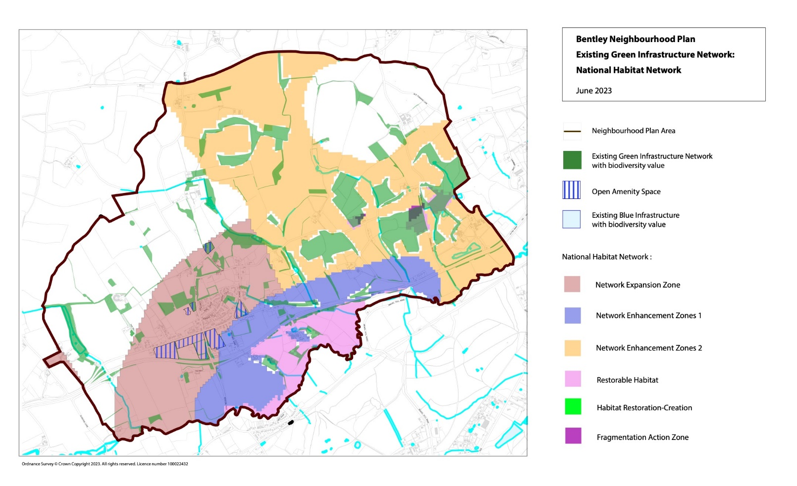
Plan E: Biodiversity Net Gain Opportunities: National Habitat Network

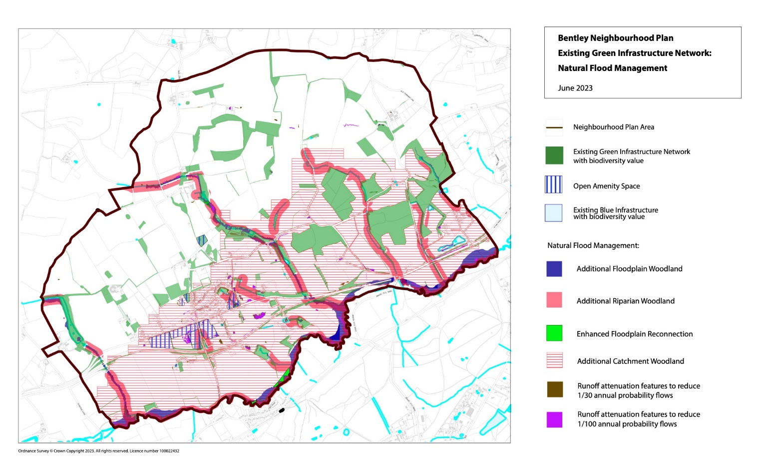
Plan F: Biodiversity Net Gain Opportunities: Natural Flood Management

Policy BEN11: Local Green Spaces

A. The Neighbourhood Plan designates the following locations as Local Green Spaces as shown on the Policies Map and will resist proposals for housing or other inappropriate development on:

- the Recreation Ground
- Carters Meadow
- the allotment site by Somerset Field
- the Old Recreation Ground
- the green space at Somerset Fields
B. Proposals for inappropriate development on the land will be resisted other than in very special circumstances as defined by national planning policy.

4.65 This policy proposes a number of important green spaces in the Parish to be protected from development by the designation as Local Green Spaces in accordance with the §105 and §106 NPPF. The other main open spaces in the Parish are used for other informal leisure pursuits. As Bentley has limited local green spaces for relaxation and activity where possible
the extension of public open spaces should be sought in line with the East Hampshire policy of increased provision.

4.66 In each case, the green spaces are an integral part of the parish and are therefore regarded as special to the local community. The BPNP Local Green Spaces report (in the
evidence base) sets out the case for each site to be designated. Once designated, the policy will resist all proposals for development unless it can be clearly demonstrated they are minor, they are ancillary to a public recreation use or they are required utilities development.

Policy BEN12: Sustainable Drainage and Wastewater

A. All proposals for residential and commercial development will be supported provided they are able to demonstrate that they maximise natural sustainable drainage where appropriate, as well as including: permeable driveways and parking areas, and soakaways, to manage the risk of surface water flooding.

B. Any new development will need to ensure that appropriate provision and any necessary mitigation is assessed, delivered and maintained for the lifetime of the development.

C. Proposals for new buildings, wherever possible, should incorporate grey and rain water harvesting measures to maximise efficient use of surface and waste water such as through the installation of water butts.

D. Developers will be required to demonstrate that there is adequate wastewater capacity both on and off the site to serve the development and that it would not lead to problems for existing or new users. In some circumstances it may be necessary for developers to fund studies to ascertain whether the proposed development will lead to overloading of existing wastewater infrastructure.

4.67 The policy seeks to refine policy CP25 of the EHDC Core Strategy in respect of requiring all relevant development proposals in the parish to manage the risk of surface water flooding. It prioritises the flood risk mitigation measures included in the policy to reflect the specific surface water flooding threats at Bentley. A specific objective is to maximise the use of natural sustainable drainage, since it not only manages flood risk but has other, multiple benefits such as improving water quality, increasing biodiversity and providing amenity benefits, including additional public open space integrating with cycling and walking routes and providing additional habitat. This policy accords with §167 and §173 NPPF.

4.68 Drainage has historically been a cause for concern in Bentley. Originally, problems of flooding were the dominant drainage problem. More recently the poor performance of the Bentley Sewage Treatment Works (STW) has added a further complication. The parish sits on the north side of the River Wey North, a chalk stream of significant ecological value. Apart from natural drainage into the river, domestic drainage also enters the river, after treatment, adjacent to the STW. It is therefore paramount that the STW functions properly and within its design parameters. Failure to do so would result in pollution of the river and damage to wildlife downstream from the STW outlet. It is, therefore, distressing that raw sewage outflow from the STW, monitored by local ecologists, Thames Water and the Environment Agency, has had a devastating effect on the river and particularly invertebrate life.

4.69 There are three causes of the pollution entering the river:

1. The sewage system in the Bentley Catchment Area is mixed such that domestic sewage and rainfall are drained by the same system. At times of high rainfall
the STW can be overwhelmed and excess flow is diverted around the works into a “lagoon”. Once full the lagoon overflows through an open ditch to the river.

2. The sewage system in the Bentley Catchment Area is old and, in places, in poor repair. Groundwater ingress from natural drainage adds significant volumes to the system, particularly after heavy rainfall, particularly in more geologically permeable strata, e.g. Upper Greensand and Chalk outcrops towards Froyle.

3. Housing development in recent years appears to have had a pronounced effect on sewage volumes reaching the STW. Although Thames Water argue, based on their modelling, that there is “headroom” within the system that would allow further development to be accommodated, it is difficult to justify this view given the conspicuous pollution overflowing from the STW. In 2022 the Bentley STW spilled 62 times for a total of 595.90 hours into the River Wey (source: The Rivers Trust Sewage Map)

4.70 At the same time, Bentley has struggled with chronic flooding due to its topography and geological setting. In short, run-off from the hillsides to the north of the village during heavy rainfall and the impermeable nature of the Gault Clay, which underlies much of the village, combine to cause overflow from ditches and drains into roads, gardens and some houses in the village. Ironically, groundwater ingress, stated above, is a less significant problem in Bentley than in other parts of the catchment area. However, although the timing of groundwater and surface run-off entering the sewage system from the same episode are different, the combined effect in some periods of rainfall must exacerbate the problem.

4.71 Thames Water is taking steps to tackle the STW problem by installing a storm surge tank (planned commissioning in late 2024). Thames Water is monitoring groundwater levels at several key sites to locate leaks into the pipe system. However, any repair work will not begin until the start of the next budget cycle in 2025. Finally, given the current state of the sewage system, any further housing development is likely to exacerbate pollution based on the evidence that the STW is already beyond current design parameters. Hence the policy requirement for evidence to demonstrate that the timing of new development will fit with the phasing of improvements to the STW.

Policy BEN13: Dark Skies

A. Development proposals will be permitted where they conserve and enhance the intrinsic quality of dark night skies.

B. Development proposals must demonstrate that all opportunities to reduce light pollution have been taken, having due regard to the following hierarchy:

- The installation of lighting is avoided; or
- If lighting cannot be avoided, it is demonstrated to be necessary and appropriate, for its intended purpose or use any adverse impacts are avoided or if that is not achievable, then adverse impacts are mitigated to the greatest reasonable extent.

4.72 This policy seeks to retain for the benefit of the local community and wildlife the existing dark skies, which have traditionally characterised the parish.

4.73 Bentley adjoins the northern border of the South Downs National Park. To support their Dark Skies Policy, SD8, Bentley observes a similar dark skies policy, wherever possible, to prevent light pollution to the national park. This accords with §191 NPPF.

5. Implementation

5.1 The modified Bentley Neighbourhood Plan (BPNP) will be implemented through a combination of the local planning authority’s consideration and determination of planning applications for development in the parish, and through steering public and private investment into a series of infrastructure proposals contained in the plan and set out below.

5.2 These proposals have emerged during the preparation of the BPNP and, although they cannot form part of the statutory land use policy provisions of the BPNP, they are included in this section as non-statutory proposals to provide a comprehensive view of local community aspirations for the parish.

Development Management

5.3 Most of the policies contained in the modified BPNP will be delivered by landowners and developers. In preparing the modified BPNP, care has been taken to ensure, as far as possible, that the policies are achievable.

5.4 Whilst the local planning authority will be responsible for development management, the Parish Council will also use the modified BPNP to frame its representations on submitted planning applications. It will also work with the District Council to monitor the progress of sites coming forward for development.

Extension of the Conservation Area

5.5 The Parish Council proposes that an appraisal of the Bentley Conservation Area is undertaken with a view to the boundary being extended to include land to the south of the Old Main Road and opposite the Recreation Ground to protect the landscape value of this area.

Infrastructure Projects

5.6 The Parish Council proposes community aspirations in the following projects for investment of future Community Infrastructure Levy funding (or s.106 contributions) allocated by East Hampshire District Council and to the Parish Council:

- Replacement sports pavilion at the Recreation Ground to provide improved facilities for scouts and sports. This facility would be sited to allow an extension to the existing car park.

- Upgrade the playing surface at the Recreation Ground, including the installation of a new cricket square.

- Education - Investment in Bentley Primary School to increase capacity and improve facilities for the increased population.

- Communication - High speed broadband provision, to permit more home working and reduction in unnecessary travel.

- Environment
- Investment in improved mains drainage for foul sewage and surface water to reduce the risk of flooding.
- Investment in the electricity supply locally, to reduce the frequent power cuts.

- Footpaths – provision of a pedestrian access way from Bonners Field to Eggars Field to facilitate children walking to Bentley Primary School.

- Transport
- Introduction of traffic calming measures, especially at the Main Road/Hole Lane crossroads.
- Improved access onto the A31 going eastwards by the construction of an entry slip road at the Froyle end of the village.
- Improved access onto the A31 going westwards by the construction of an entry slip road from River Road.
- Introduction of flashing speed signs where appropriate to control speeding through the village.
- Improvements in car parking capacity at Bentley Station, Bentley Primary School and by the shops.
- Increased local bus services, especially in the evenings and at weekends.

5.7 This series of local infrastructure projects will be prioritised for investment from the Neighbourhood portion of the Community Infrastructure Levy (CIL) as well as for applications for the release of District CIL. The prioritisation and timing of these projects will be assessed by the Parish Council with regard to community need and affordability.

5.8 The CIL will be charged on qualifying residential and commercial development. 25% of the levy collected from development in the Parish will be passed to Bentley Parish Council directlt to invest in the Parish. The above detail provides the local community with an indication of the priorities for investing the fund to improve local infrastructure as a result of new development in the parish.

5.9 In addition, other policies of the modified BPNP may require planning obligations to be entered into as part of planning consents to finance and deliver specific infrastructure projects relating to the development scheme in order to make the scheme satisfactory.

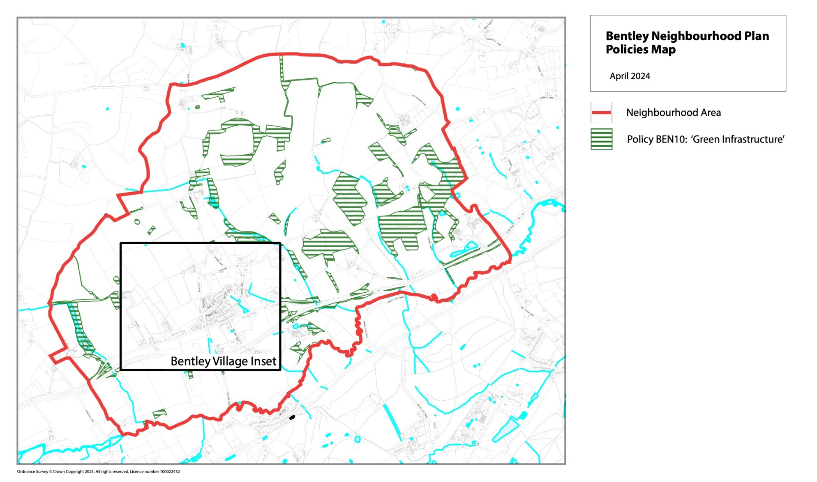
Plan G: Policies Map

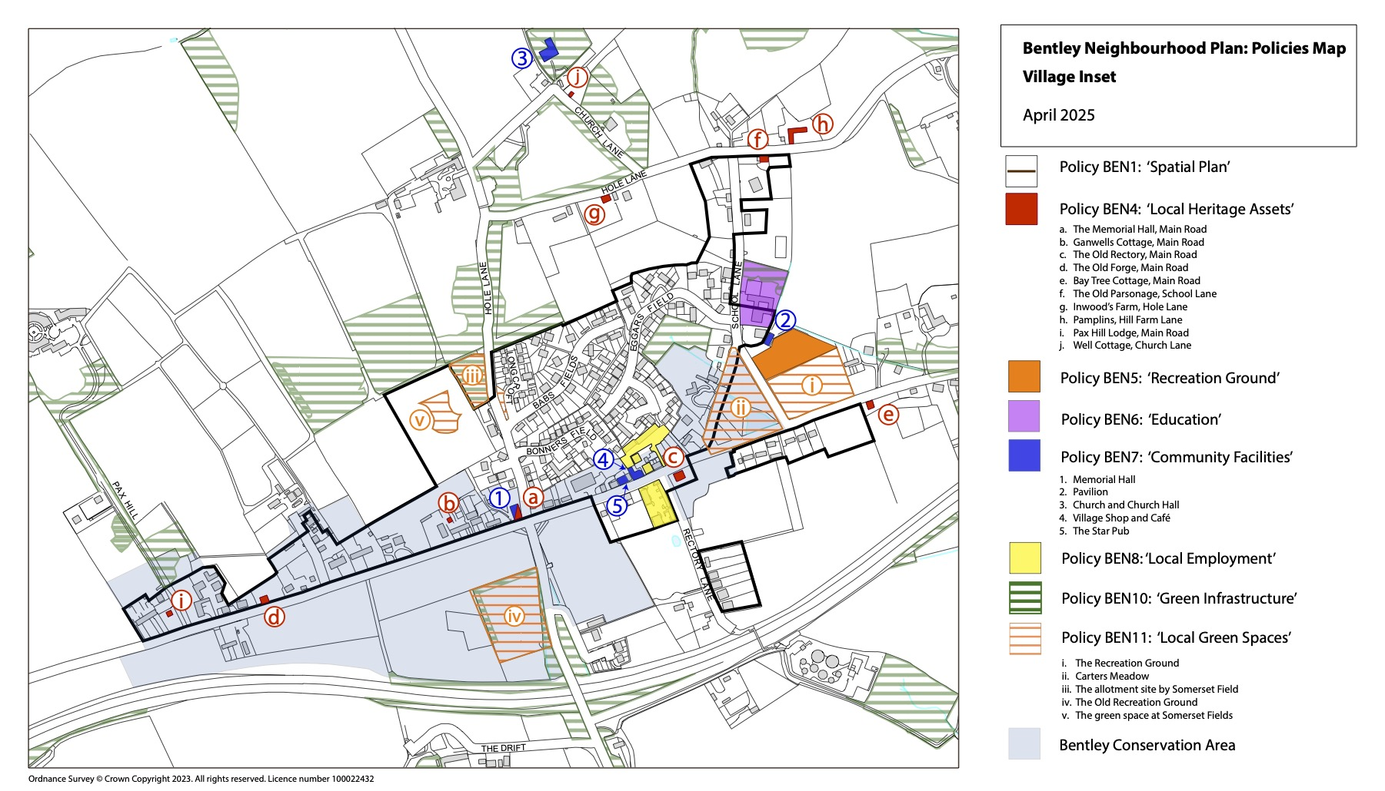

Plan H: Policies Map – Village Inset

Appendix A – Evidence Base

The list below contains all those documents collected and reviewed in the process of preparing this report. All are available to view via the Bentley Parish Council website’s neighbourhood plan pages or the East Hampshire District Council Planning Policy pages.

Bentley Parish Plan (2012)
Bentley Local Green Spaces Report (2023)
East Hampshire District Council Joint Core Strategy (2014)
East Hampshire District Council Reg 18 Issues and Priorities (2022)
East Hampshire District Council Local Plan Part 2 (2016)
East Hampshire District Council Regulation 18 Part 2 (Jan 2024)
East Hampshire District Council Regualtion 18 Part 2 site allocations (Jan 2024)
East Hampshire District Council Land Availability Assessment (updated 2023)
East Hampshire District Council Parish Profiles – Bentley (2006/2007)
EHDC Landscape Capacity Study 2018
EHDC Local Plan: Housing Needs and requirements (2022)
EHDC Sustainability Appraisal (SA) Interim Scoping Report ( 2018)
The Whitehill-Bordon Eco Town Transport Assessment (2012)

The Whitehill-Bordon Eco Town Traffic Management Transport Strategy

The Bentley Traffic Survey (2018)
Bentley Analysis of Traffic Counters 2012 - 2018
Bentley Village Character Assessment ( June 2023)
Bentley Conservation Area Character Appraisal ( 2014)
Hampshire County Council School Places Plan ( 2024 - 28)
Hampshire County Council Bentley Primary school admissions (2023 - 2026)
Historic England: Local Heritage Listing: Identifying and Conserving Local Heritage
Bentley Neighbourhood Plan 2015 - 2028
EHDC Housing Outside Settlement Boundaries SPD (2023)
EHDC Residential Extensions and Householder Development SPD (2018)
EHDC Guidance on the loss of Industrial or Business Use (2021)
EHDC Biodiversity Planning Guidance (2021)

EHDC Community Facilities Study (2023 updated version)
EHDC Open Spaces, Sport and Recreation Study (2018- 2028)
EHDC Settlement Hierarchy 2022
Bentley Parish Biodoversity Bible
Bentley Wildlife

Appendix B – Bentley Settlement Boundary
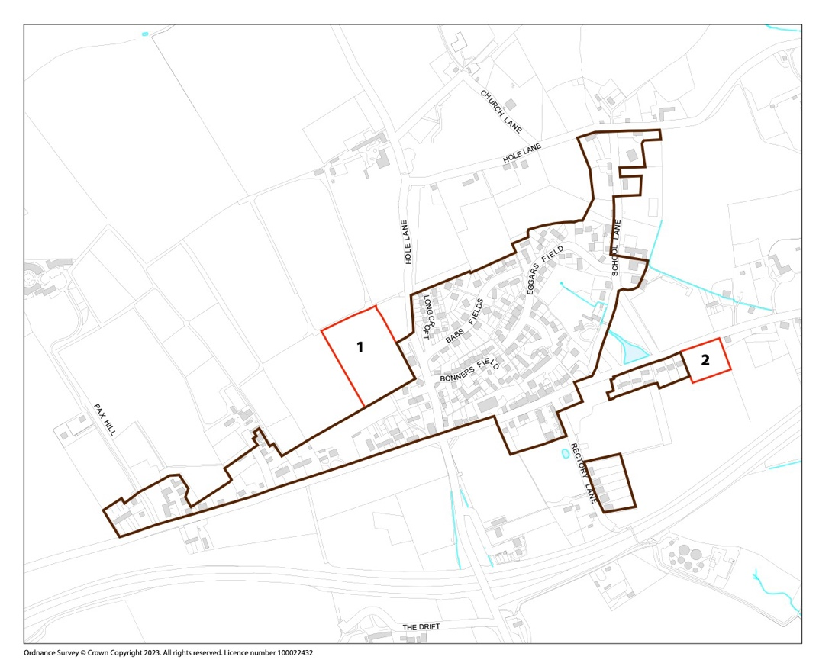
Map Ref | Location/Description | Criteria | Consideration/Recommendation | Action | Evidence
1 | Land to west of Hole Lane | 2a | Planning permission granted for 37 dwellings in 2015 (55417/001) | Redraw boundary to include planning permission. | Aerial, Mapping, Application info (55417/001), Site Visit
2 | Land west of Bay Tree Cottage, Main Road | 2a | Planning permission granted for 5 dwellings in 2015 (55233). | Redraw boundary to include planning permission. | Aerial, Mapping, Application info  (55233), Site Visit

Plan I: Illustrating the two changes to the existing Bentley Settlement Boundary (Highlighted in red)

In the table above criteria 2a refers to the EHDC Interim Settlement Policy Boundary review 2024 principles which state:

2a) Settlement Boundaries will include ‘Existing commitments i.e unimplemented planning permissions and implemented permissions.

Appendix C – Local Heritage Assets

Apart from the Grade 2 listed buildings in the parish, there are some notable buildings that are not listed but have a distinct and valued local character, history and appearance that are worthy of retention. The Bentley Village Character Assessment, June 2023, includes details of the buildings selected

The Memorial Hall

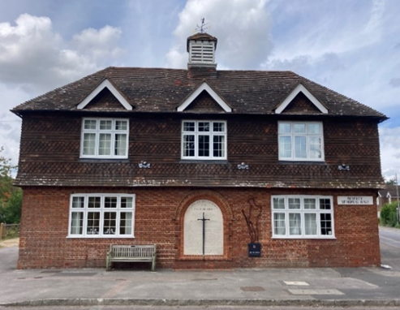
Prominently located at the village crossroads and characterising the entrance to the village from the south, stands the Bentley War Memorial Hall. It was built in 1923 on a site presented by Thomas Eggar in memory of the men who died in the 1914–18 War; the centrally mounted memorial plaque was extended to commemorate the fallen of Bentley in the 1939-45 war. The front façade is symmetrical presenting a red brick elevation on the ground floor with tile hung upper floor and clay tiled roof with central cupola. The hall extending behind the original building, built after WW2, is less attractive and is not included in the non-designated heritage asset listing.

Ganwells Cottage

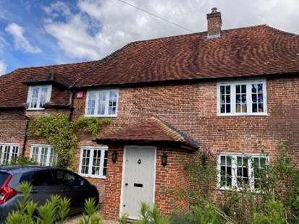
The building is red brick with a half hipped red clay tile roof is typical of the style, design and materials which characterise the village. The front façade is symmetrical around a central front door with casement windows on both sides. There is an extension to the west, almost the same size as the original property in a similar style, although the eaves are lower and the upper floor has two dormers to the front. The building is bounded to the Main Road by a tall red brick wall.

The Old Rectory
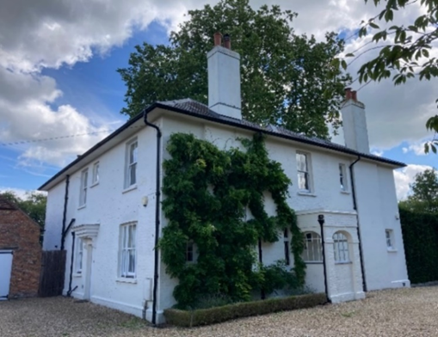
Regency style house with white painted brickwork to elevations and shallow pitch slate roof. The original property was built in 1780 as a classical two bay Georgian property facing south towards the River Wey; the kitchen was to the cooler north side of the house facing the Main Road. The house retains chimneys and decorative porches. Walls on the south façade are lime rendered and scribed, painted off-white, the other facades are more utilitarian; painted red brick. The property was extended in the Victorian period, between 1840 and 1870. Although the Georgian hipped roofs were retained, later windows were larger paned Victorian sashes, several of these are in the Venetian style. The house was home to Jane Austen’s brother, Henry, from 1827 to 1839.

The Old Forge
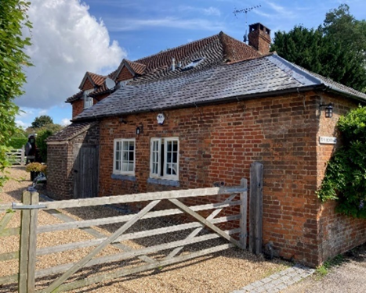
The Old Forge is an attractive two storey dwelling with red brick and tile hung elevations and with both slate and plain clay tiled roofs. Windows are timber and leaded casements. It is a typical example of a number of older properties that characterise the village.

Bay Tree Cottage
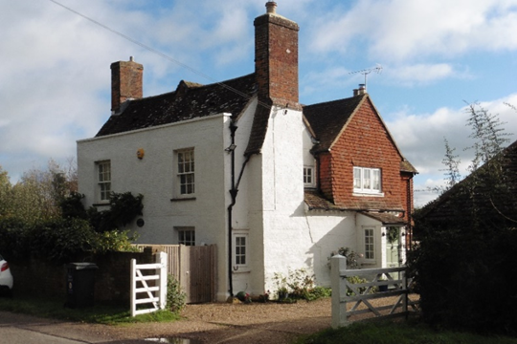
A painted brick Georgian dwelling with sash windows and parapet coping oriented to the road. Behind the parapet is a red tiled pitched roof with prominent chimney breasts and stacks at either end of the front ridge. Tile hung gables to the rear. The property is a distinctive feature of the eastern side of the village.

.

The Old Parsonage

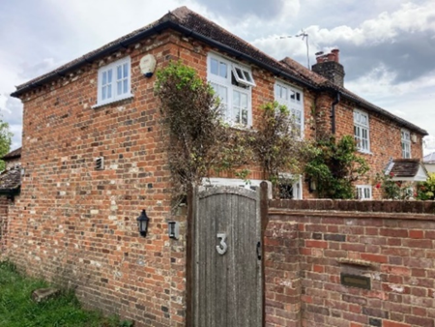
The building includes three two storey bays each with hipped red tile roofs. Two of the three bays extend eastwards forming the bulk of the property. The Old Parsonage has clearly been extended and renovated at various times in its history. Most elevations are brick, however, the north elevation towards the rear is Malmstone with brick quoins and cills. It is bounded by a tall brick wall to the road.

Inwoods Farm
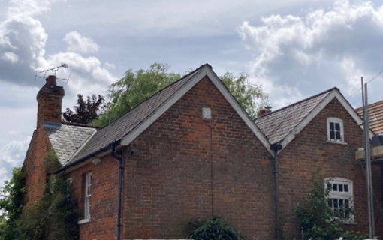
This Georgian building is built in red brick with slate roofs. There are three roofs with valleys between. The third element viewed from the entrance is hung with tiles from the roof line down.

Pamplins
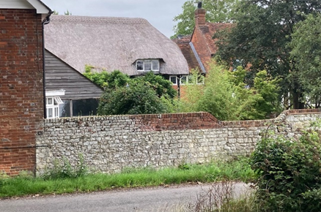
This extensive property sits in a large amount of land behind brick and stone walls. The western half of the property is thatched and the eastern half is a clay tiled roof. Both wings are built in red brick. It has a cottage at the front entrance leading on to a gravel driveway with timber built garages and stabling for horses.

Well Cottage
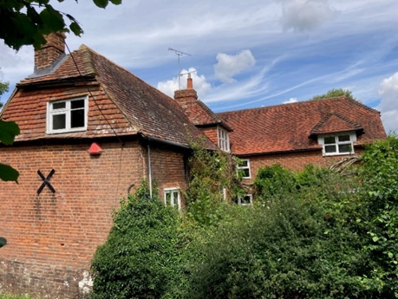
This red brick building dates from 1650 and sits adjacent to the lane in well designed gardens. A southern extension was added in the 1980s in keeping with the style of the original cottage, also in red brick and with a clay tiled, half hipped gable ended roofs. The roofs include neat, unobtrusive dormers to light the upper floor rooms.

Pax Hill Lodge
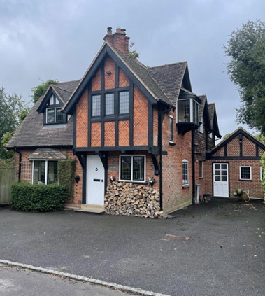
During the early part of the 20th Century, up to the Second World War there appears to have been little residential building. A notable exception is at the western end of the village on the Pax Hill Drive where there are three Arts and Crafts style houses built in 1907. They are black timber framed with herringbone red brick panels. Windows are leaded casements. The roofs are red clay tiled, cross gabled, with the upper floor within the roof space. Some of the chimneys are quite ornate; The Lodge has four interlocking diamond stacks.

