  Food Hygiene Rating Scheme:  Appeal form | 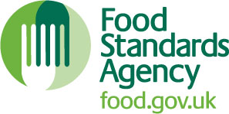

Notes for businesses:

- As the food business operator of the establishment you have a right to appeal the food hygiene rating given following your inspection if you do not agree that the rating reflects the hygiene standards and management controls found at the time of the inspection.
- You have 21 days (including weekends and bank holidays) from the date of receipt of the notification letter to lodge an appeal.
- Please use the form below and return it to the Lead Officer for Food from your local authority – contact details are provided with the written notification of your food hygiene rating.
- The Lead Officer for Food will review your rating and communicate the outcome of your appeal to you within twenty one days.

Business details
Food business operator/proprietor:

Business name:

Business addresses:

Business tel. number: |  | Business email:

Inspection details
Date of inspection: |  |  | Food hygiene rating given:
Date notified of rating:

Appeal
I do not agree with the food hygiene rating given by the food safety officer because (please explain below under each of the three headings).

Compliance with food hygiene and safety procedures:

Compliance with structural requirements:

Confidence in management/control procedures:

Signature:
Name in capitals:

Position: |  | Date
Please now return this form to: East Hampshire District Council, Monterey House, Bedford Road, Petersfield, Hampshire, GU32 3LJ or email: ehealth@easthants.gov.uk

